Research about native British animal habitats.  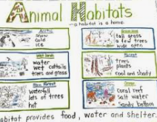 | Make a model to show a habitat  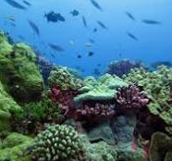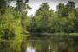 | Find out about native British trees and present it in an interesting way.  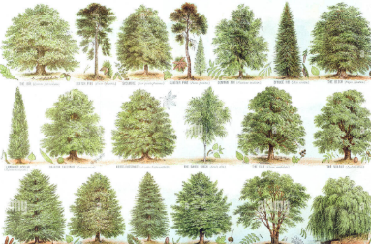
Create a book review of a book that you would recommend to someone in the class.   | Design your own unique plant and label its features.  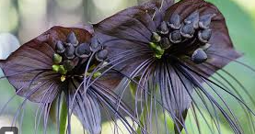  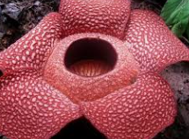  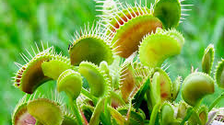  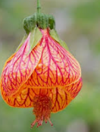 | Go outside and make a weather proof den either for yourself or a toy and bring in some photos of it, with either yourself or a toy inside.  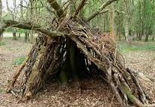
Create a storyboard to summarise a film you have seen this year.  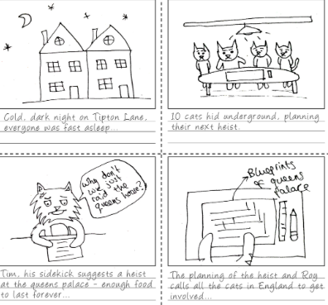 | Make a PowerPoint about a sport that you are interested in.   |       Take photos of yourself reading to a variety of different people and in different places (at least 5)
Homework Fun for Sycamore Class SUMMER 2025
Ideally we would like you to complete two of these activities each half-term which would be 4 projects to complete before the end of the summer. We will always try to celebrate homework as soon as practically possible.

