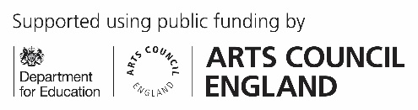

September 2026

Dear Parents and Carers,

I am pleased to say that spaces are now available for Piano Keyboard lessons at
Loxwood Primary School.

Weekly lessons take place during school hours.

Lesson options available are:
Group or 10-minute individual length lessons, 20-minute or 30-minute length lessons

Further information can be found on the WSM website. www.westsussexmusic.co.uk

The current cost for lessons: £9.90 for group lessons, or 10-minutes allotted for each pupil,
£17.20 per 20-minute individual lesson or £25.70 per 30-minute individual lesson.

If you would like to apply for lessons you can do so on our website at: https://www.westsussexmusic.co.uk/make-music/music-lessons/

If you have any questions, please email me at janet.macnamara@westsussexmusic.co.uk

Best wishes,

Mrs Janet Mac Namara LRAM Prof.Cert.(Hons)RAM
Visiting Piano Keyboard Teacher
West Sussex Music
www.westsussexmusic.co.uk

West Sussex Music, Sanford House, 5 Medwin Walk, Horsham, RH12 1AG

A company limited by guarantee registered in England and Wales

Company No: 8524556 Registered Charity No: 1152703

Office: 01403 286330
music@westsussexmusic.co.uk
www.westsussexmusic.co.uk

