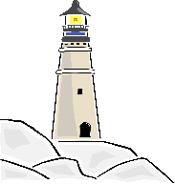
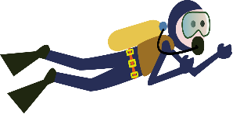
Year 1 Home Learning Projects
Summer Term - Make a Splash!
Please complete 2 of these projects each half term so that by the Summer Holidays you will have completed at least 4 of the activities below. These activities are designed to get your creative juices flowing and to be a great opportunity to develop your learning with support from someone at home. We are really looking forward to sharing what you have learnt and the new skills you have developed.
Green Fingers  We will be finding out all about plants in Science. Have a go at planting some seeds and see what you can grow!  We’d love to see a picture of you and your plant! Perhaps you could record what happens to your plant, using pictures, photos or sentences? | Ocean in a bottle  With a few simple items you can create an ocean in a bottle.  Ocean in a Bottle | Easy Science Experiments For Kids - YouTube  We would love to see a picture or video of your ocean in a bottle so why not upload it to Tapestry so we can share it with the class. | Time’s Up!  Brush up on your telling the time skills.  Can you help your family to tell the time? Have a go at making your own clock and using it to help you to learn to tell the time. Or maybe you might like to draw a timetable of a typical day at your house with times for the things that you usually do, like getting up or going to bed.
A Splash of Colour!  We are going to be learning some painting techniques used by famous painters such as Monet, Turner and Hockney.  Maybe you could have a go at painting in a similar style? Perhaps you might set up your own gallery at home? We’d love to see what masterpieces you create! | Row your Boat!  We are going to be learning about Grace Darling  Who was Grace Darling? - BBC Bitesize  Towards the bottom of the page is a QUIZ. Write your own quiz and bring it in to share with everyone. | Off to the beach!  Plan a trip to the beach.  Remember to plan what you will need for your trip. Will you need a bucket and a spade to make sandcastles? Will you need your swimming outfit and a towel to go into the sea?  We'd love to hear all about it. You could send us a postcard or write a diary entry about your day at the beach; don't forget to include some pictures.

Don’t forget to practice your reading at home and record it in your Reading Record

