Researchit  Research famous environmental artists and consider how you display your research, make it interesting.  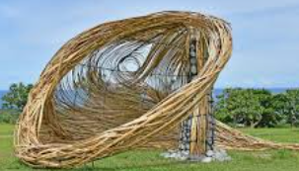  Skills –to learn about great artists, architects and designers in history. | Writeit/ Filmit  Can you write a menu in French with food that you would like to eat?  If you would like you could video yourself and a friend as a customer and a waiter  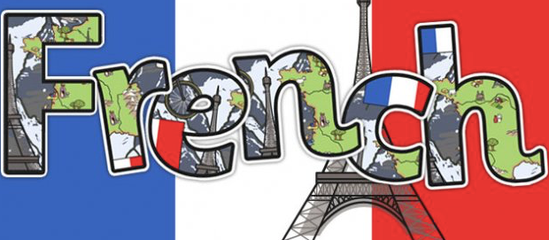  Skills – to describe people, places, things and actions orally and in writing. |  | Reviewit  Create a book review of a book that you would recommend to someone in the class. See examples below:  http://www.loxwoodschool.com/website/childrens_area/33060  Skills – to participate in discussions about books that are read to them and those that they can read for themselves. |  | Createit  Research a famous collage artist. Then create a fruit of vegetable collage inspired by your chosen artist.  Skills - to learn about great artists, architects and designers in history. | Representit  Can you design and create a way to represent the stages of the life cycle of a plant? You could: use paper plates; make a poster; create a small book; create a presentation.  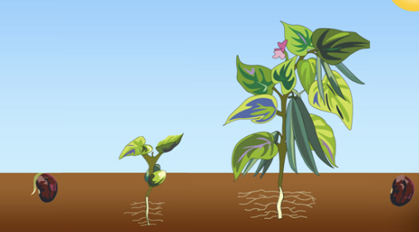  Skills – to report on findings, including oral and written explanations, displays or presentations
Designit  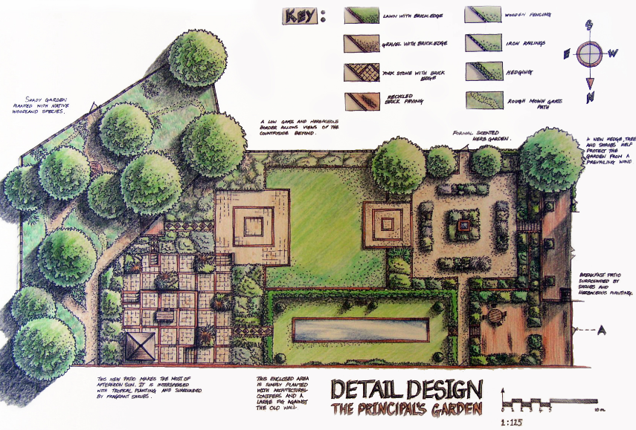  Design your own garden. Identify the various features e.g. walls, grass, trees, ponds.  Skills – to use drawing to develop and share their ideas, experiences and imagination. |  | Summariseit  Create a storyboard to summarise a book you’ve read this year.  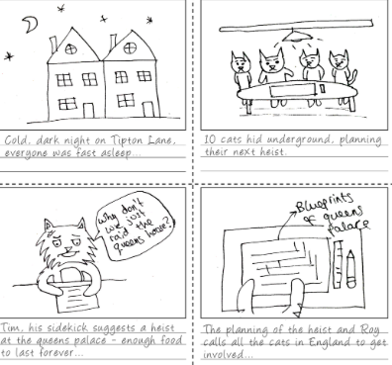  Skills – to identify main ideas drawn from more than one paragraph & summarise these. | Mapit  Show which countries the different plant explorers visited by marking their voyages on a world map. Can you use a different colour for each pant hunter? Draw sketches of the plants they found in the countries they are originally from.  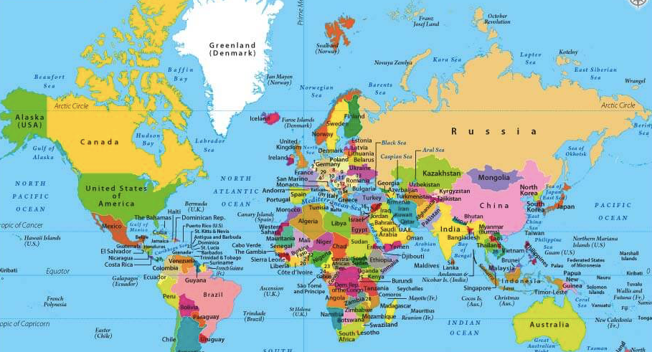  Skills – to locate the worlds countries, using maps. | Designit  Design a flag of your choice, using a variety of shapes and angles. Label the shapes and angles you have used.  Skills – to identify angles, horizontal and vertical lines and pairs of perpendicular & parallel lines. |  | Researchit  Create a fact file for a famous plant hunter. Find out where they lived, where they went to school and which plants they collected.  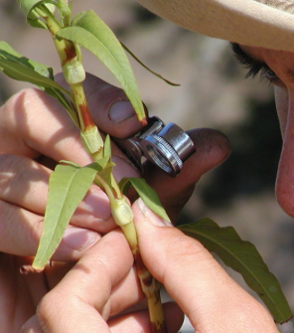  Skills – to use search technologies effectively.

We would like you to complete two of these activities each half term which would be four projects by the summer holidays.
We will always try to celebrate homework as soon as practically possible.

Suggested hand-in Dates: 4th May, 18th May, 8th June, and 29th June. Please complete no more than one of each colour.

