Sycamore Class
Autumn 2024
You will be expected to complete two activities per half term, to a high standard! Please tick off this sheet to show which projects you have chosen.
Researchit  Find out about the Ancient Egyptians and present your research in an interesting way. For example,  Clothes: What did they wear?  Gods: who did they worship?  Jobs: What jobs did they do every day?  Technology: Which objects made life easier?  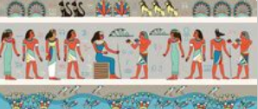  Skills - to develop a secure knowledge and understanding of changes in the Ancient world. | Compareit  Compare two books by the same author. What similarities do they have? How are they different?    Skills – to identify themes and conventions in a wider range of books. | Factfindit  Create a fact file on the digestive system. Find out what is made up of and how it works.  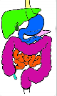  Skills – to use search technologies effectively. | Quizit  Use your knowledge of Europe to create a quiz for Sycamore class to do.  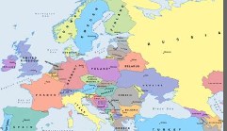  Skills – to ask relevant questions; to identify regions of Europe, capital cities and languages.
Numéroit  Can you create a word search including the French numbers in words 1-10?  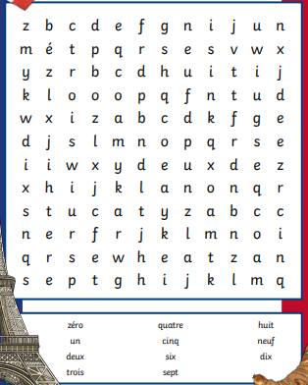  Skills – to develop a knowledge and understanding of French numbers 1-10. | Makeit  Can you make a model of a pyramid?  You can use any materials you have at home or find outside for example, matchsticks, stones, food, clay, lego etc.  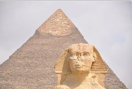  Skills – to develop a secure knowledge and understanding of changes in the Ancient world. | Singit  Can you record yourself singing the 3, 4 or 8 times table or all three!    Skills – To enhance times tables knowledge. | Designit  Can you design a PowerPoint on how to keep safe online?    Skills – to improve skills and develop understanding of how to use a Microsoft application.
Key skills

