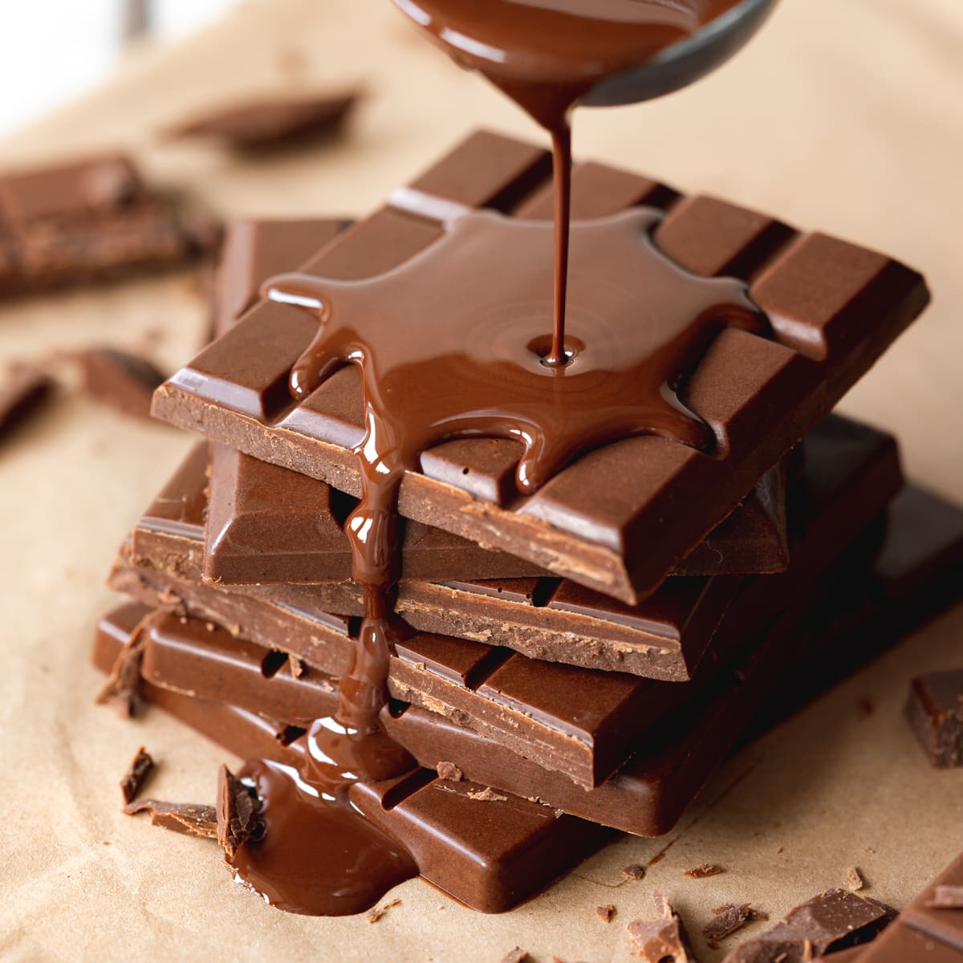  Explore the journey of chocolate.  Research how chocolate is made - from cocoa bean to chocolate bar. Draw and/or explain each stage. | 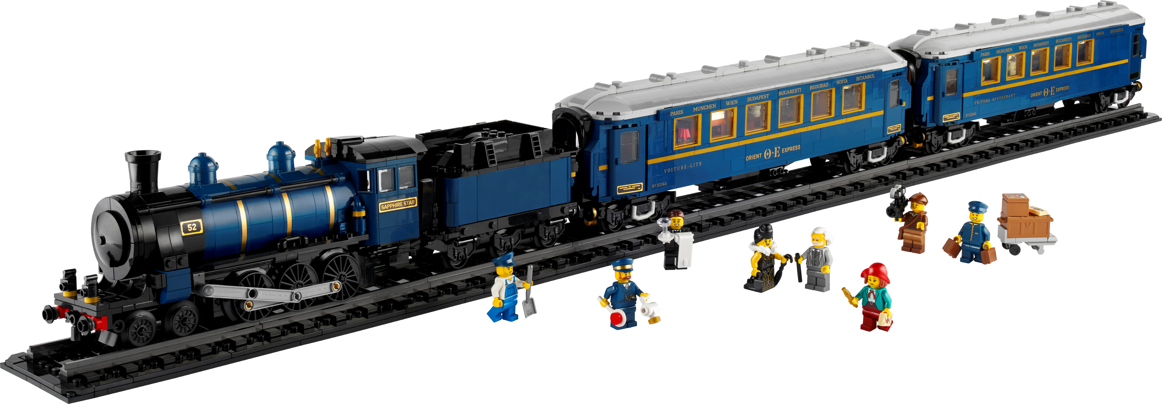  Make a model of a train or railway station.  Use cardboard, Lego, recycled materials, or natural items. | 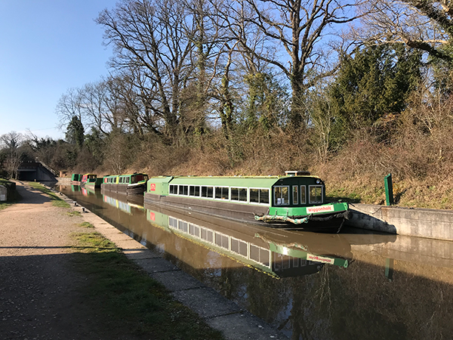  Find out about animals that live in Campania or Loxwood.  Present your findings as a mini fact file or poster.
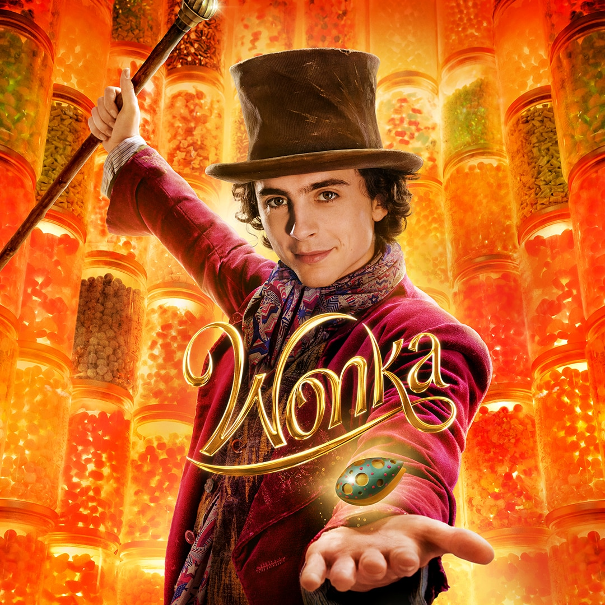  Imagine you are Wonka and create a chocolate bar advert.  Design packaging and write a short slogan. | 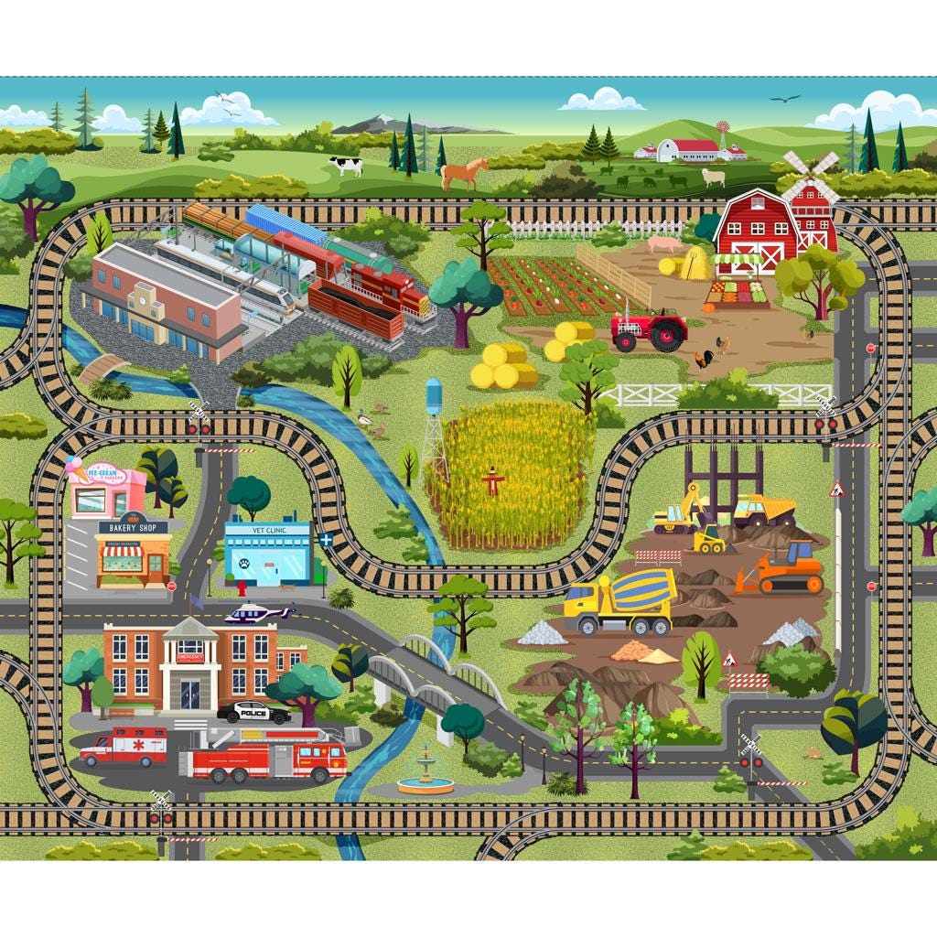  Design your own railway map.  Include fictional stations with habitat names (e.g. Pond Junction, Woodland Halt). | 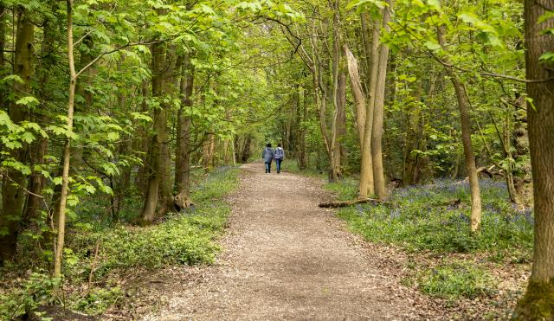  Go on a nature walk.  Take photos or make a list of 5 different living things you spot in a local habitat.
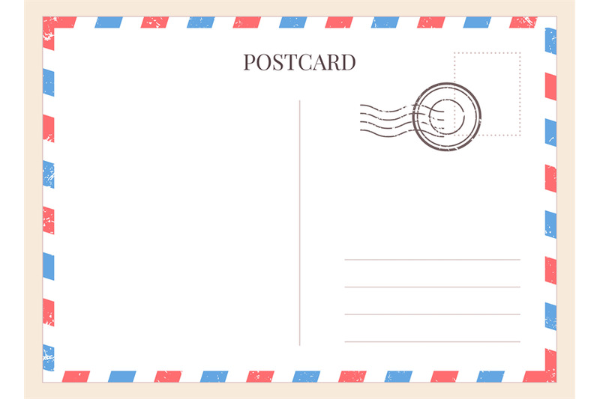  Write a postcard from Loxwood or Campania.  Describe the landscape, weather, animals, or food as if you're visiting. | Make a poster about how trains have changed over time.  Include pictures, facts, and fun train trivia.  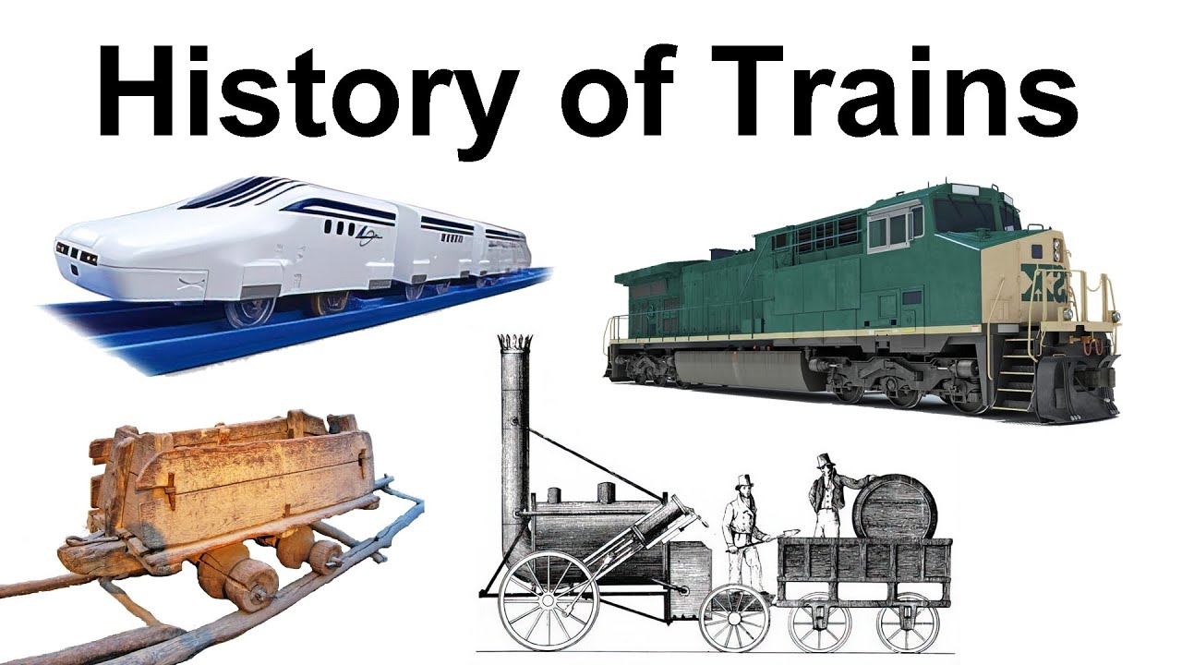 |   Take 5 photos of yourself reading in different places.  Write a couple of sentences telling us where you are and why you are reading there.  Try to choose places linked to nature or travel.
Homework Fun for Sycamore Class AUTUMN 2025
Ideally we would like you to complete two of these activities each half-term which would be 4 projects to complete before the end of the summer. We will always try to celebrate homework as soon as practically possible.

