Science
Living Things and their Habitats
- Recognise that environments can change and that this can sometimes pose dangers to living things
- Describe how living things are classified into broad groups according to common observable characteristics and based on similarities and differences including microorganisms, plants and animals.
- Give reasons for classifying plants and animals based on specific characteristics.
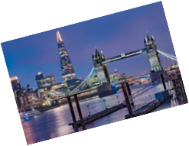
Art
Cityscapes – the study of various artists and their techniques when creating cityscapes:
- 3d Pop Art-Textured Appearance
- Silhouettes
- Reflections
- Creating an ink drawing.

PE
- Cricket
- Athletics
- Tennis
- Rounders

RE
Worship
Focus on aspects of worship across different faiths. They will explore what worship is, what it means and how believers worship differently. They will consider different forms of worship and discuss freedom to worship around the world.
English
Significant Author (Shakespeare)
- Recount
- Poetry (Free Verse)
- Letter Writing
-play scripts

Independent Writing
- City non-chronological report

End-of-year Play
-Prepare poems and plays to read aloud and to perform,
-showing understanding through intonation,
-tone and volume so that the meaning is clear to an audience

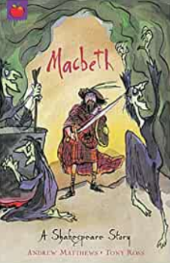
Music
‘Beauty & The Beast’ End of Year Production
Singing – choral and solo arrangements. End of Year Performance

DT
Fairground-design, build and create their own rotating fairground rides:
- pulley and belt systems
- electrical circuits with motors
- Design and create their own ride

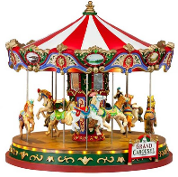
YEAR 5
SUMMER TERM
Lights, Camera, Action!
RHE

- Changing Me (puberty, and sex education – Y6 only)
- Dreams and Goals (transition)

Geography
Marvellous Maps
- Follow a short route on a OS map Describe the features shown on an OS map
- Use atlases to find out data about other places

French
‘This is France’
Learn key vocabulary and phrases related to France and the capital city- Paris. Learn specific vocabulary to describe France in terms of its neighbours and the position/distances of a variety of cities. Learn the French names for famous French landmarks and how to describe what people do when they visit Paris. Learn about famous French people and learn the French names for the areas that they were / are famous for. They will also learn key phrases connected to the themes throughout the lessons.

Computing
Radio Station
Use software and digital devices for recording sound. Based around a theme of a radio station, children will be encouraged to take a creative approach that includes interviewing, making adverts and using jingles. They will evaluate their own content.
Maths
Decimals: adding and subtracting decimals within 1 and crossing the whole.
Multiplying and dividing decimals by 10,100, and 1000
Properties of shape:
Measuring angles in degrees
Using a protractor
Drawing lines and angles accurately.
Calculating angles on a straight line and around a point
Triangles and quadrilaterals.
Position and direction:
Translation and with coordinates
Symmetry
Reflection and reflection with coordinates
Converting units:
Kilograms and kilometre
Millimetres and millilitres
Metric units
Measurement:
Volume: comparing, measuring and estimating volume and capacity.

History
Leisure and Entertainment
Develop their knowledge of modern British history and understanding of changes over time. Think about the impact of leisure and entertainment on society and people’s everyday lives. Learn about how changes to working hours and pay gave people more capacity to afford holidays, more time to play sport and follow their music, movies, television and gamine in 20th century. Children will use knowledge acquired to draw their own conclusions about which aspects of leisure and entertainment they think had the most impact.

Science
Animals including Humans
- Explore the changes that human beings experience as they develop to late adulthood including puberty and late adulthood and death.
- Learn about the life cycle of a human being.
- Compare the gestation period of humans and other animals and investigate the development of babies.
- Look at the body as humans get older and look at how the life expectancy of humans has changed over time

