Dear Parents and Carers,
You may recall a parent/carer survey launched last term to inform the governors how well families are aware of and understand the vision and values of the school. In addition, governors wanted to know how well the school communicated and promoted its values within the school and community.
The survey was shared via the newsletter and in person at a parent's consultation afternoon. On my part it was lovely to meet with some of you and witness the positive and informative nature of such an event.
A few figures:
From the many returns and helpful responses here are just a couple of headline figures.
86% of returns were very or somewhat familiar with the schools' vision and values.
Most thought the main five school values were well promoted in school.
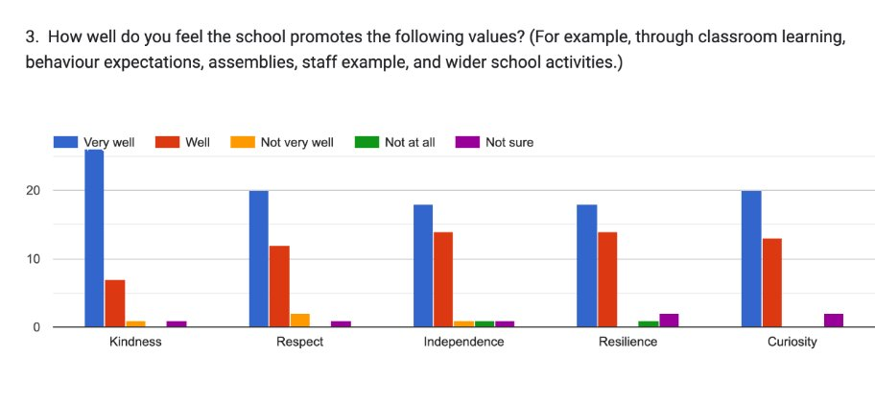
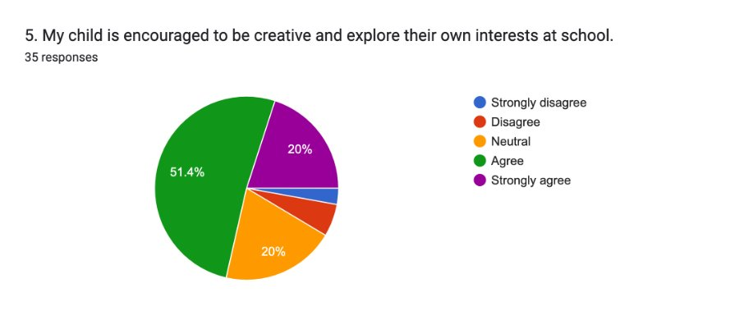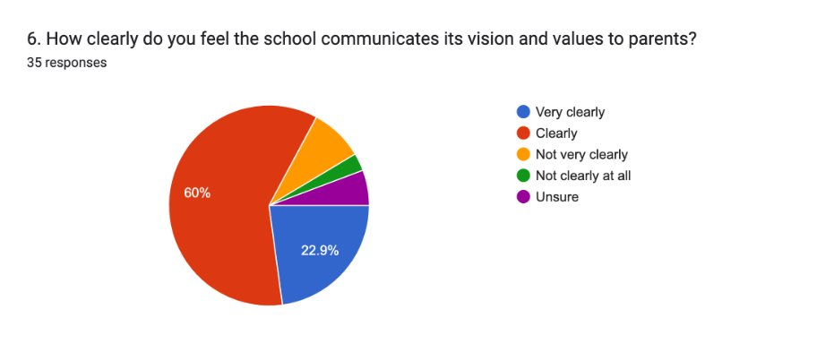
Summary of Findings
The parent survey indicates that most parents are aware of the school’s vision and values and feel they are reflected positively in the school’s ethos and daily practice. Parents commonly encounter these through school communications, the website, and their children’s experiences, with many recognising how values such as kindness, respect, and resilience are promoted.
The majority of respondents believe the school effectively encourages a positive approach to learning, including resilience, creativity, and a growth mindset. Communication is generally seen as clear, although a small proportion of parents reported limited awareness or understanding, suggesting some inconsistency in how messages are reaching all families.
Overall, the findings show strong parental support, alongside an opportunity to further opportunities strengthen awareness and consistency.
Our next steps from your comments:
- Continue to promote the vision and values regularly through newsletters, the website and school events.
- Increase visibility through displays and references in communications with parents.
- Provide opportunities for parents to engage more closely with how the values are embedded in learning.
- Review impact periodically, including through future surveys, to ensure all families understand and feel connected to the school’s vision.
I would like to thank you for your contributions, time and comment in relation to this survey and for your continued support.
Mr Phil Bellas (Chair of Governors)

