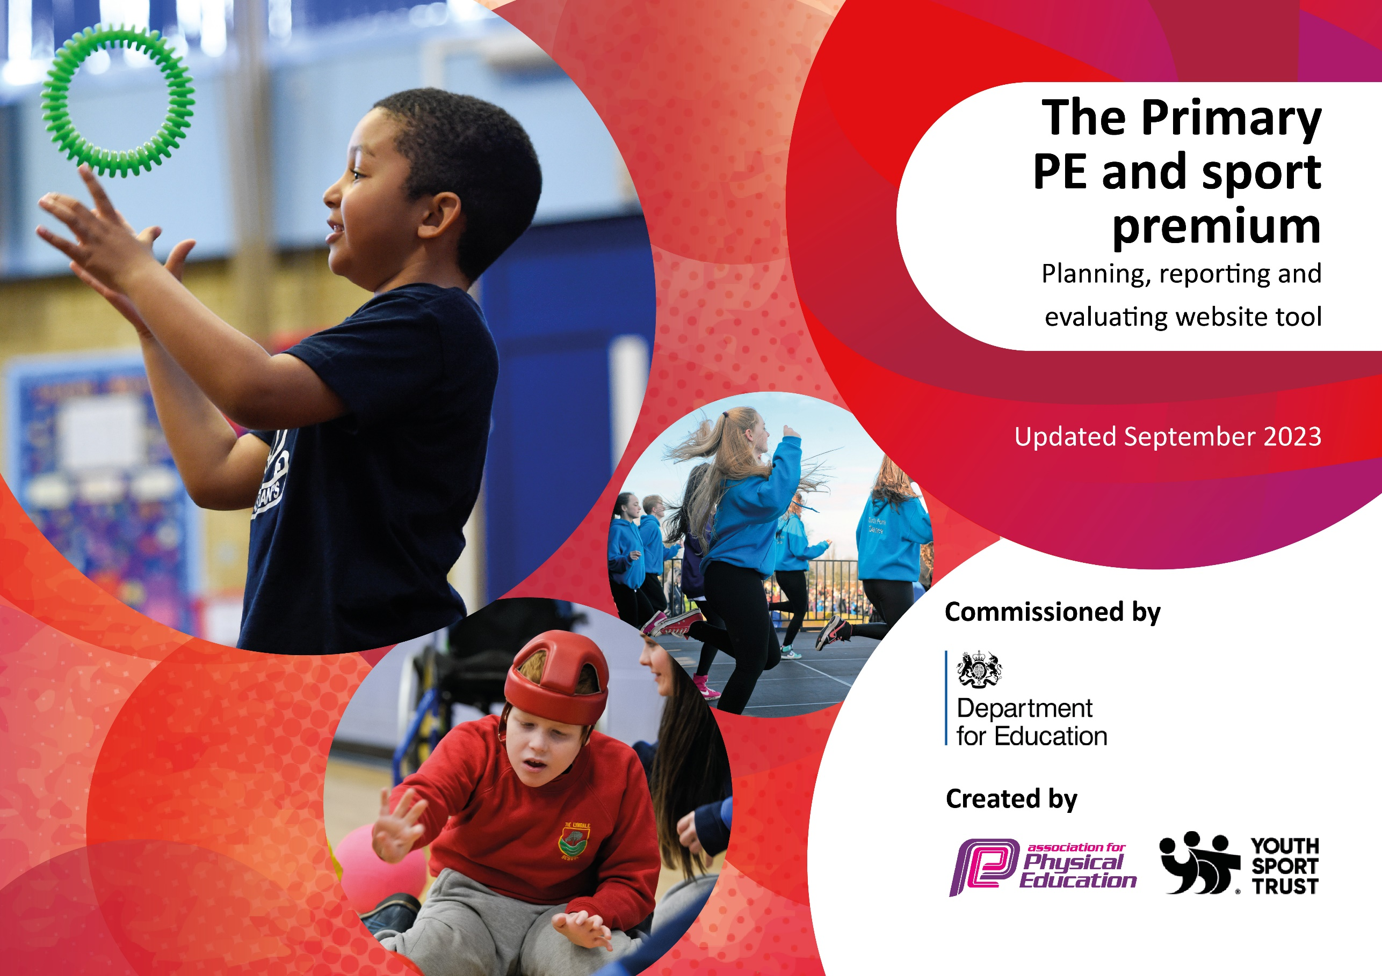

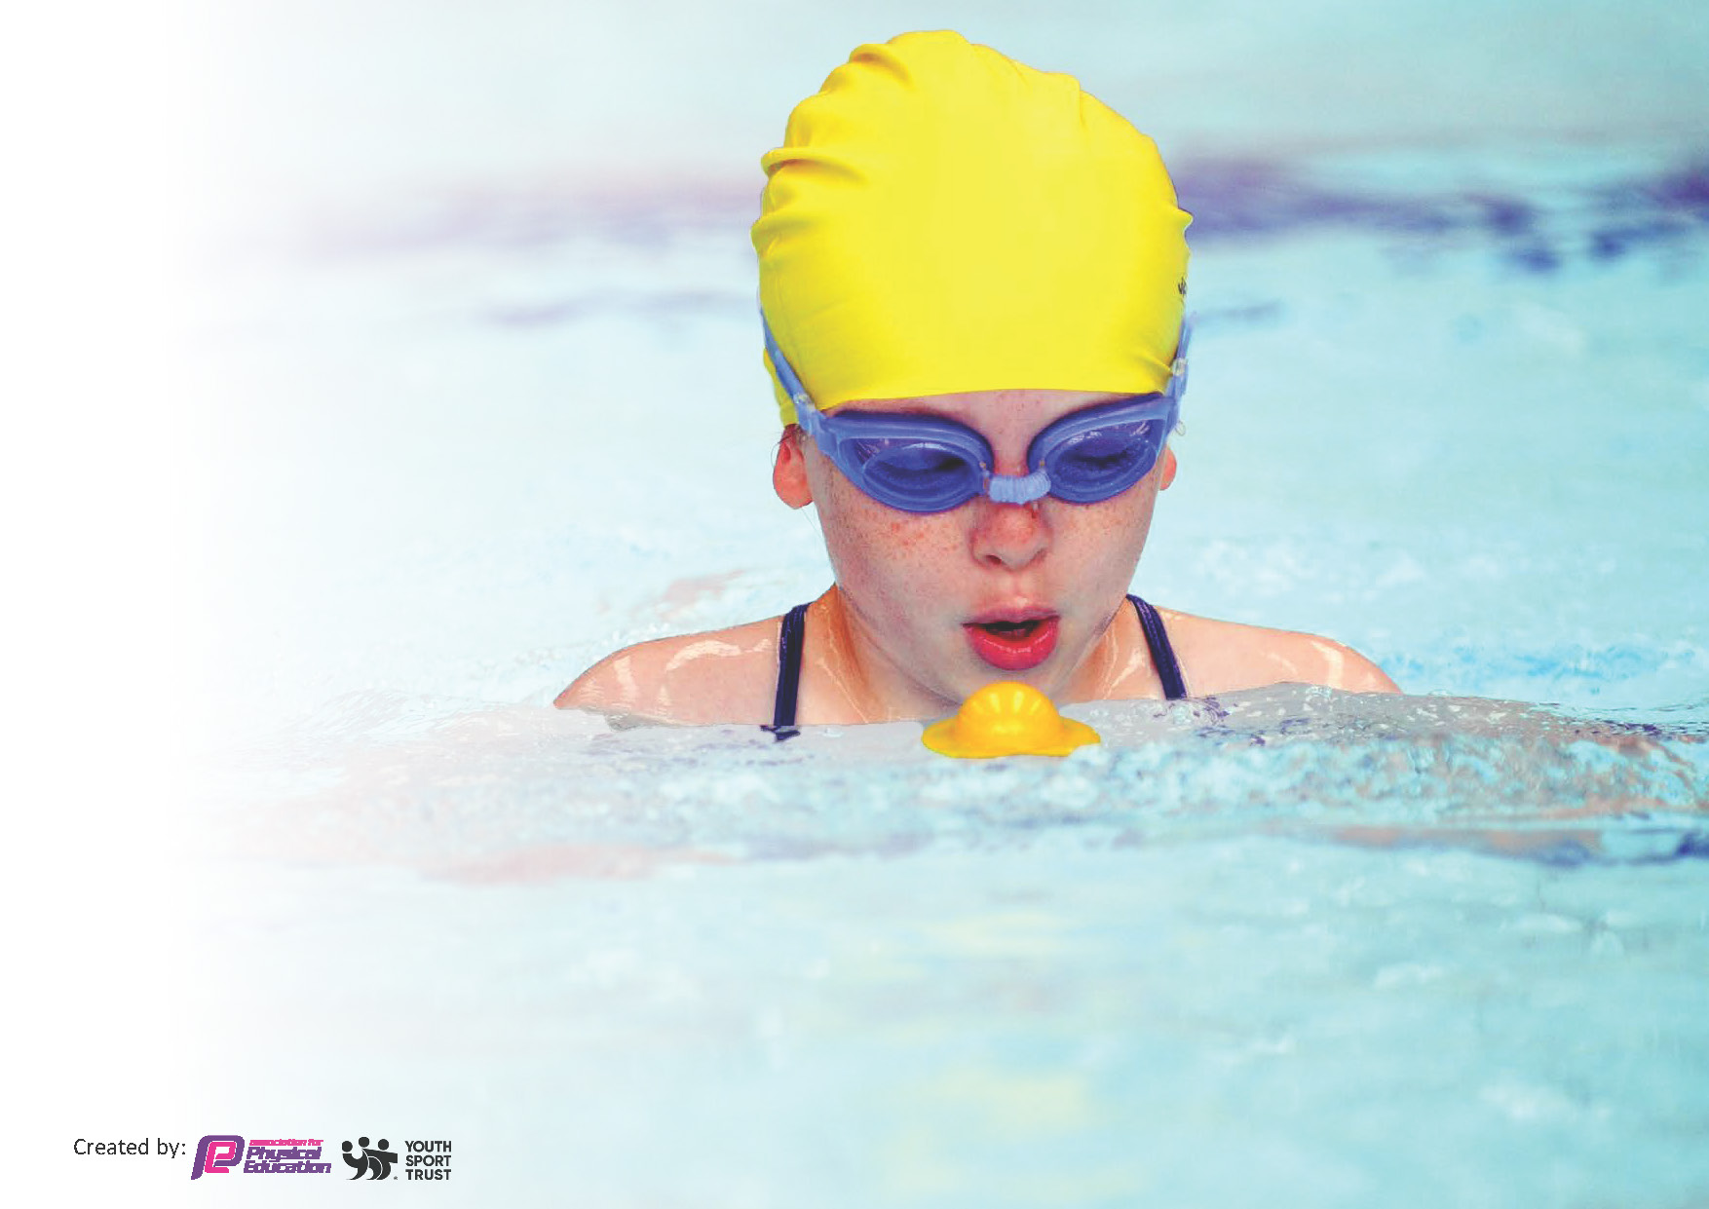
This template can be used for multiple purposes:
by:
- It enables schools to effectively plan their use of the Primary PE and sport premium
- It helps schools to meet the requirements (as set out in guidance) to publish information on their Primary PE and sport premium
- It will be an effective document to support Ofsted inspections enabling schools to evidence progress in Physical Education (PE) and evidence swimming attainment, which forms part of the PE National Curriculum. We would recommend schools consider
the Intent, Implementation and Impact of any spend, as examined within the Education Inspection Framework.

It is important that your grant is used effectively and based on school need.

Schools must use the funding to make additional and sustainable
improvements to the quality of the PE, School Sport and Physical Activity (PESSPA)
they offer. This means that you should use the Primary PE and sport premium to:

- Build capacity and capability within the school to ensure that improvements made now will benefit pupils joining the school in future years
- Develop or add to the PESSPA activities that your school already offers.

The Primary PE and sport premium should not be used to fund capital spend projects; the school’s core budget should fund these. Further detail on capital expenditure can be found in the updated Primary PE and sport premium guidance.

The Primary PE and sport premium guidance, outlines 5 key priorities that funding should be used towards. It is not

necessary that spending has to meet all the key priorities, you should select the priorities that you aim to use any funding towards.

Although completing this template is not a requirement for schools, schools are required to publish details of how they spend this funding. Schools must also outline what the impact this funding has had on pupils’ PE and sport participation and attainment and how any spending will be sustainable in the future. All funding must be spent by 31st July 2024.

The Department for Education has worked closely with the Association for Physical Education (afPE) and the Youth Sport Trust (YST) to develop this template and encourages schools to use it. This template is an effective way of meeting the reporting requirements of the Primary PE and sport premium.
Review of last year’s spend and key achievements (2022/2023)

We recommend you start by reflecting on the impact of current provision and reviewing your previous spend.

Activity/Action | Impact | Comments
Key indicator 1: The engagement of all pupils in regular physical activity – Chief Medical Officers guidelines recommend that primary school pupils undertake at least 30 minutes of physical activity a day in school. | Children are more active in school (with more classes using movement breaks including Jump Start Johnny.  All KS2 children have been provided with 2 hours of physical education p/w (within the curriculum only); and have had extracurricular provision in addition to this.  Playtime equipment (including climbing wall for KS1 & 2) has been replaced and introduced to keep children more active.  There have been subsidiesed extra-curricular sports clubs for KS2. | Pupils are more active in PE lessons – take part without stopping to rest.  Attitudes to learning improved – better concentration in lessons.  While the activity levels at playtimes have improved in the short-term, it will need reviewing regularly as the equipment doesn’t last.  Consider how we can offer this out to KS1 next year too? Also, how can priority be given to disadvantaged and SEND children so it is not just first come first served for free clubs.
Key indicator 2: The profile of PE and spot is raised across the school as a tool for whole school improvement. | A large proportion of children are recognised in assemblies each week for their sporting achievements.  The UTTM (Up to the Minute) that goes out weekly & Facebook keeps parents informed with upcoming dates as well as sports reports.  The notice board is full of information about fixtures, clubs, sports reports and pupils are keen to get involved.  All four junior classes had 6 weeks of swimming lessons for the first time in 5 years. Improved swimming data – 25% more children in Year 6 can perform safe self-rescue in different water-based situations. | The SLT have seen the benefits of the raised profile and is committed to funding these areas if the Primary PE and Sport premium is discontinued. This is ongoing and will continue to remain a focus next year as SLT value it as a USP for the school.  Consider how we can reach more parents – introduction of Instagram?  Due to the increasing costs of swimming, and the fact that all children in the juniors have had swimming last year, we will not continue with swimming for the next few years.
Key indicator 3: Increased confidence, knowledge and skills of all staff in teaching PE and sport. | Staff meetings provided essential CPD for all staff on knowledge and skills progression in PE. They also received training on the Learning to Lead initiative.  Team teaching with Mr Green (a specialist PE teacher) has increased the quality of teaching and learning. Staff are more empowered to teach a wider range of sports successfully. High quality lessons ensure children are encouraged and active throughout. | Training was successful. Next year, we need to ensure staff are taking up the more personalised CPD that has been offered by the locality (especially for ECTs).  Mr Green to continue working with the school in a similar capacity, ensuring he is covering different sports. This will lead to sustainability as all staff will be supported to feel confident to deliver PE and Sport both within and outside the curriculum.
Key indicator 4: Broader experience of a range of sports and activities offered to all pupils. | Planning and timetabling shows a range of sporting activities offered to all pupils. Planning shows progressions of skills from EYFS to Y6 through the utalisation of Get Set for PE.  The children tried new sports with specialist teachers: yoga, tri golf, skateboarding, scootering, street dance.  Competed in 8 inclusive competitions which resulted in 10% more junior children participating in sporting opportunities. | Planning is sustainable but the timetabling and activities will need reviewing each year as the dates of events change so annual reviews are necessary.  Children enjoyed the new sports on offer and some have been inspired to continue out of school.  This will remain a priority for next year focusing on SEND and disadvantaged children.
Key indicator 5: Increased participation in competitive sport. | All junior children participated in a Level 1 competition.  92% of junior children represented the school in a Level 2 competition - increased by 10% from last year (which was 82%).  We attended 19 sports events throughout the year, with opportunities from all classes from Year 1 to Year 6:  - Inclusive x8  - Competitive x 8  - Talented Athlete x 3 | Consider varying the sports on offer for Level 1 or including an additional event.  Continue to keep up the competition offer for 2023-2024 (taking into consideration pupil voice especially targeting those who didn’t participate last year).

Key priorities and Planning
This planning template will allow schools to accurately plan their spending.

Action – what are you planning to do | Who does this action impact? | Key indicator to meet | Impacts and how sustainability will be achieved? | Cost linked to the action
Improve the extra-curricular offer for all children (during lunch time and after school). | Lunchtime supervisors / teaching staff, coaches - as they need to lead the activity.  Pupils – as they will take part. | Key indicator 1: The engagement of all pupils in regular physical activity.  Key indicator 2: The profile of PE and sport is raised across the school as a tool for whole school improvement.  Key indicator 4: Broader experience of a range of sports and activities offered to all pupils. | More pupils meeting their daily physical activity goal, more pupils encouraged to take part in PE and Sport Activities.  Parents and children will be aware of all the clubs on offer.  More children will participate in extracurricular sport with a focus on SEND and disadvantaged children. | £500 for Sports Leader Training with Mr Green.  £1000 for new equipment to ensure playtimes are more active.  £700 for a TA to run an afterschool club to ensure more SEND and disadvantaged children have access to free sports clubs after school.  £*** to fund Kickstart clubs for disadvantaged and SEND children.
CPD for teachers. | All teaching staff and teaching assistants. | Key Indicator 3: Increased confidence, knowledge, and skills of all staff in teaching PE and sport. | Primary teachers more confident to deliver effective PE supporting pupils to undertake extra activities inside and outside of school, and as a result improved % of pupil’s attainment in PE. | £5000 for all staff to undertake CPD throughout the year with specialist coach.  £500 for subscription to Get Set for PE to improve the quality of PE lessons and ensure progression from EYFS to Y6.
Enter & participate in a wider selection of sporting events throughout the year. | All staff – as they will be asked to attend and supervise children at events.  Receptionist – increased admin to ensure permissions have been given.  Pupils – as they will take part. | Key indicator 2: The profile of PE and spot is raised across the school as a tool for whole school improvement.  Key indicator 4: Broader experience of a range of sports and activities offered to all pupils.  Key indicator 5: Increased participation in competitive sport. | More pupils will meet their daily physical activity goal and encouraged to take part in Level 1 and Level 2 competitions. | £2000 for competition entry and supply teacher cover to ensure children are fully supervised at events.  £700 for Bronze package through Weald Locality.
Apply for Platinum School Games Mark. | PE Coordinator – ensure all children have been offered opportunities throughout the year & completed all the admin / paper work necessary.  Receptionist – record keeping of participation at events and clubs.  All teaching staff to ensure all children are being provided with the same opportunities. | Key indicator 1: The engagement of all pupils in regular physical activity.  Key indicator 2: The profile of PE and spot is raised across the school as a tool for whole school improvement.  Key indicator 4: Broader experience of a range of sports and activities offered to all pupils.  Key indicator 5: Increased participation in competitive sport. | School will achieve the Platinum School Games Award for the 4th consecutive time.  More pupils will have been given the opportunities to represent the school and try new sports in Level 1 and Level 2 competitions. | £2000 TLR for PE Coordinator.  £1,500 towards Receptionist salary to ensure time is allocated for administration for all sports events.
Plan and carry out a compreneshive Sports Week which inspires all children – promoting EUROS 2024 & Paris Olympic Games 2024. | PE Coordinator – find new activities that children wouldn’t usually experience. Timetabling the week to ensure all children participate.  All teaching staff to ensure all children are being provided with the same opportunities.  Pupils – as they will take part. | Key indicator 1: The engagement of all pupils in regular physical activity.  Key indicator 2: The profile of PE and spot is raised across the school as a tool for whole school improvement.  Key indicator 4: Broader experience of a range of sports and activities offered to all pupils. | All children will experience new sports (Olympic Odyseey, freestyle football, break dancing, beat boxing and boogie bounce). | £3,000 for new activities during Sports Week.

Key achievements 2023-2024
This template will be completed at the end of the academic year and will showcase the key achievements schools have made with their Primary PE and sport premium spending.

Activity/Action | Impact | Comments
Key indicator 1: The engagement of all pupils in regular physical activity – Chief Medical Officers guidelines recommend that primary school pupils undertake at least 30 minutes of physical activity a day in school. | All KS2 children have been provided with 2 hours of physical education p/w (within the curriculum only); and have had extracurricular provision in addition to this.  We have a formal structure to engage out young people through Sports Leaders and use them to support our offer. Sports Leaders were engaged in active lunchtimes throughout the year for KS1 children.  Playtime equipment has been replaced to keep children more active.  There have been subsidiesed extra-curricular sports clubs for all of KS2 as well as Pupil Premium children for KS1. Club information has been sent to all disadvantaged children first ensuring they get priority.  94% of parents who replied (85/110) to the ‘Active Minutes’ Questionnaire ticked yes to say their child does participate in 30 minutes of physical activity a day outside of school. This is 15% more than last year. | Pupils are more active in PE lessons – take part without stopping to rest. Attitudes to learning improved – better concentration in lessons.  Behaviour has improved at playtimes for KS1 children are more active and participating in more structured games. Next year, consider how Sports Leaders can be used to support active play for KS2 as well.  While the activity levels at playtimes have improved in the short-term, it will need reviewing regularly as the equipment doesn’t last.  This has had a positive impact with a larger proportion of disadvantaged children (across the school) attending sports clubs. This will need to continue next year.  Continue to provide more opportunities especially for the disadvantaged and SEND children to try and increase this to 100% of children. Could we provide more lunch clubs for those who are unable to attend due to alternative commitments afterschool? Could we provide funded spaces for holiday clubs for some of the least active children?
Key indicator 2: The profile of PE and sport is raised across the school as a tool for whole school improvement. | More children are being recognized in assemblies each week for their sporting achievements (both in school and external events including: horse riding rosettes; swimming and trampolining certificates; and football medals and trophies).  The UTTM (Up to the Minute) continues to share sporting events and reports. The sports page on the school website has kept parents up to date as well as Facebook and the newly introduced Instagram. This has enabled us to reach more parents.  Successful application for Platinum School Games award for the 4th consecutive times acknowledges the opportunities provided for all children. | The SLT have seen the benefits of the raised profile and is committed to funding these areas if the Primary PE and Sport premium is discontinued. This is ongoing and will continue to remain a focus next year as SLT value it as a USP for the school.  This has really helped raise the profile of PE and sport across the school as parents are more aware of all the clubs and events on offer and how the competitions have gone.  This has been celebrated with the community to raise the profile of PE and Sport.
Key indicator 3: Increased confidence, knowledge and skills of all staff in teaching PE and sport. | Staff meetings provided essential CPD for all staff on knowledge and skills progression in PE. They also received training promoting the importance of Physical Literacy (the motivation, physical competence and confidence to be active for life).  Team teaching with Mr Green (a specialist PE teacher) has increased the quality of teaching and learning. Staff are more empowered to teach a wider range of sports successfully. High quality lessons ensure children are encouraged and active throughout. | Training was successful. Next year, we need to ensure staff are taking up the more personalised CPD that has been offered by the locality (especially for the two new ECTs).  Mr Green to continue working with the school in a similar capacity, ensuring he is covering different sports. This will lead to sustainability as all staff will be supported to feel confident to deliver PE and Sport both within and outside the curriculum.
Key indicator 4: Broader experience of a range of sports and activities offered to all pupils. | Planning and timetabling shows a range of sporting activities offered to all pupils. Planning shows progressions of skills from EYFS to Y6 through the utalisation of Get Set for PE.  The children tried new sports with specialist teachers: Olympic Odyssey (VR experience of Olympic Games), freestyle football, break dancing and beatboxing and Boogie Bounce.  Year 5 children received 6-week block of lessons from a specialist tennis coach.  Year 4, 5 & 6 children all received a 6-week block of lessons from a specialist Dance Instructor.  Promoted EUROs 2024, Olympic Games 2024 and Wimbledon to inspire more children. | Planning is sustainable but the timetabling and activities will need reviewing each year as the dates of events change so annual reviews are necessary.  Pupil voice ascertained, shows the children enjoyed the new sports on offer and some have been inspired to continue out of school. Continue to offer a broader range of experiences next year to ensure all children are inspired and motivated. What new sports can we find?
Key indicator 5: Increased participation in competitive sport. | All junior children participated in at least one Level 1 competition. We added an extra opportunity this year with 6 sports on offer (not just 5 like last year).  96% of junior children represented the school in a Level 2 competition - increased from last year (which was 92%). All children in Year 5 & 6 competed. All children in juniors were selected and invited! 242 participants in sports events throughout the year!  We attended 17 sports events throughout the year. Street Cricket and Dance were new this year.  There were opportunities from all classes from Year 1 to Year 6:  - Inclusive (KS1 Multi skills x 2, Year 3 Multi Skills, LKS2 Inclusive Golf & Frisbee, UKS2 Inclusive Racquet Sports, KS2 SEND Festival, Year 4 Alternative Sports)  - Competitive (Cross Country, Cross Country Finals, UKS2 Tag Rugby, UKS2 Street Cricket, KS2 District Sports, KS2 Dance, District Sports  - Talented Athlete x 3 | Consider varying the sports on offer for Level 1 or including an additional event.  Continue to keep up the competition offer for 2024-2025 (taking into consideration pupil voice especially targeting those who didn’t participate last year). Can we enter some different sports competitions to appeal to different children?

Swimming Data
Meeting National Curriculum requirements for swimming and water safety.
Priority should always be given to ensuring that pupils can perform safe self-rescue even if they do not fully meet the first two requirements of the National Curriculum programme of study

Question | Stats: | Further context  Relative to local challenges
What percentage of your current Year 6 cohort can swim competently, confidently and proficiently over a distance of at least 25 metres? | 83% | Due to COVID, increasing costs of transport and parents refusing to pay for swimming lessons, we had not had school swimming lessons for the past four years.  6% of this cohort joined us during Year 6 (after the swimming session in Year 5 which meant they did not receive school swimming lessons).  6% of this cohort, took their children out of school swimming lessons.
What percentage of your current Year 6 cohort can use a range of strokes effectively [for example, front crawl, backstroke, and breaststroke]? | 80% | Having not had any other school swimming lessons in their time with us, this cohort had to spend a lot of time building water-confidence rather than focusing on a range of strokes.  A larger proportion than normal, do not have swimming lessons outside of school.
What percentage of your current Year 6 cohort are able to perform safe self-rescue in different water-based situations? | 90% | 6% of this cohort joined us during Year 6 (after the swimming session in Year 5 which meant they did not receive school swimming lessons).  6% of this cohort, took their children out of school swimming lessons.
If your schools swimming data is below national expectation, you can choose to use the Primary PE and sport premium to provide additional top-up sessions for those pupils that did not meet National Curriculum  requirements after the completion of core lessons. Have you done this? | Yes/No | We were unable to provide ‘top-up’ sessions this year due to transport limitations. Additionally, we have been struggling to get an ad-hoc slot with one of the two local pools as they want us to commit for the year which isn’t financially viable. However, we are in discussions with our locality school as they feel this is something they can offer next year.
Have you provided CPD to improve the knowledge and confidence of staff to be able to teach swimming and water safety? | Yes/No | We do not have access to a swimming pools so lessons are currently provided by an external pool with an external teachers.  Once our staffing situation is more stable, this will be worth considering.

Signed off by:

Head Teacher: | Fi Dowley
Subject Leader or the individual responsible for the Primary PE and sport premium: | Daisy Price (Senior Teacher and PE Coordinator)
Governor: | Anna McNamara
Date: | 20/07/2024

