11th December 2024

Dear Parents and Carers,

Accelerated Reader

We wish to provide further information regarding the Accelerated Reader programme to ensure that it is being utilised to its full capacity. This is used from Year 2 upwards for selected children.

The programme comprises two distinct elements. The first is conducted in school, at least half-termly, for assessment purposes (Star Reading), which enables us to ascertain both your child's Reading Age and their Zone of Proximal Development (ZPD) or Book Level. The second element involves ongoing reading practice that we encourage students to undertake at home through Accelerated Reader. Following the completion of a book, pupils should log in (instructions are provided on the reverse side of this letter) and complete a brief quiz pertaining to the book read, which serves to assess their comprehension and understanding. While we will allocate time in school for this, it would be greatly beneficial if you could encourage your child to complete these quizzes at home as well.

It is essential that students only take quizzes on books that fall within their specific ZPD (Book Level). Although our library offers a limited selection, children may use the ‘Book Finder’ tool at [AR Book Finder](https://www.arbookfind.co.uk/default.aspx) to identify additional books that align with their interests. By selecting 'Advanced Search', you can discover more books within their ZPD that are available in our library or at local libraries and bookstores. Furthermore, there is an informative video titled ‘New to AR Bookfinder’ that provides an overview and includes a link to ‘A Parent’s Guide to Accelerated Reader Book Finder’.

Both teachers and students will be able to monitor the progress made by completing these essential quizzes.

Thank you for your continued support.

Kind regards

Miss Price and Mrs Donnellly

**Child Friendly Instructions – AR Book Quiz**

<https://login.renaissance.com/12d2c5fc-d497-4dde-b5ea-078f7ecfd3ab?state=13e76cca-b1b7-495f-aabb-96c17b288e6d>

In school, we have this saved as a bookmark / favourite for the children to make this easier.

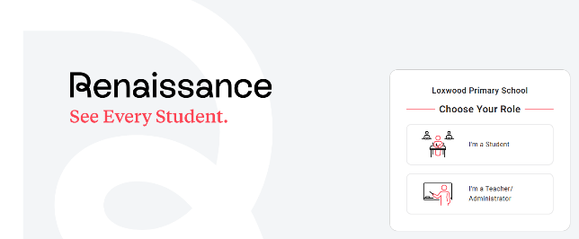

Select **‘I am a student’**

Enter your **Accelerated Reader username** and **password** which can be found in the front of your **yellow reading record** and press ‘**log in**’.

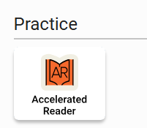

Select ‘**Accelerated Reader’**

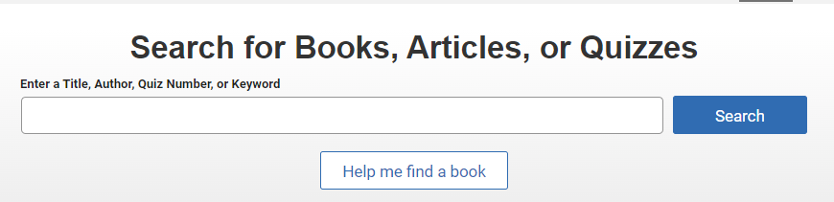**Search** for the quiz you need using the Title, Author, Quiz number or Key Word.

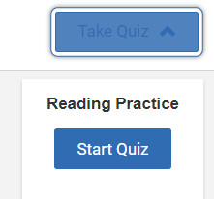

Select **‘Take Quiz’** and then **‘Start Quiz’.**

Once you have completed the quiz, write it in the back of your reading record so we can monitor how many you are doing and the scores you are getting. Now you can change your book!