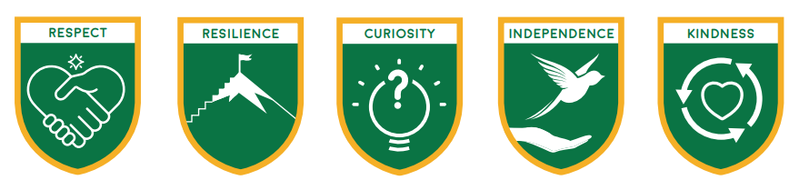

**Loxwood Learners Code:**

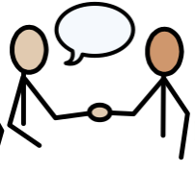

* We are kind, helpful and polite.



* We are brave enough to make mistakes which show resilience.

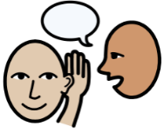

* We show respect by listening to others and taking care of our school.



* We are curious about our world and how to look after it.



* We are a good friend.

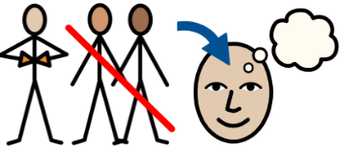

* We will show independence by taking responsibility for our learning and behaviour.