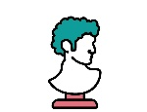
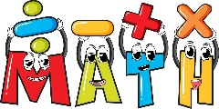

RE
Judaism
We will learn about Jewish beliefs, practices and celebrations. We will explore important symbols, stories and places of worship, and find out how Jewish people live their faith.

ART
Sculpture
We will explore pottery and sculpture to find out what they can tell us about the past. We will study different artefacts and create our own clay designs
MATHS

Place Value
Read, write, order and compare numbers beyond 1,000. Identify the value of each digit, round numbers to the nearest 10, 100 and 1,000, and solve practical problems using place value knowledge.

Addition & Subtraction
Add and subtract numbers with up to four digits using formal written methods and mental strategies. Solve one-step and two-step problems, and use estimation to check answers and explain reasoning.

Area
Compare and measure area by counting squares and using practical resources. Investigate the area of simple shapes and find ways to work it out accurately.

Multiplication & Division
Recall multiplication and division facts for the 3, 4 and 8 times tables. Use arrays, grouping and sharing to multiply and divide, and solve practical problems using these facts.
ENGLISH
Punctuation and Grammar
We will develop our understanding of punctuation and grammar to improve our writing. We will practise using commas, apostrophes, speech marks and different sentence types accurately and effectively.

Recount
We will write a recount based on Charlie and the Chocolate Factory. We will focus on organising our ideas in time order, using clear sentence structure and including interesting detail to help the reader understand what happened.

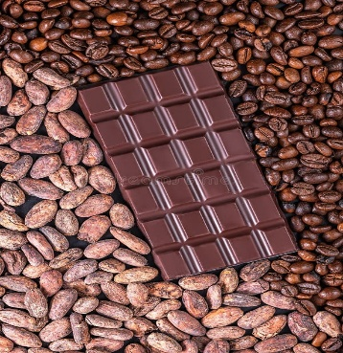
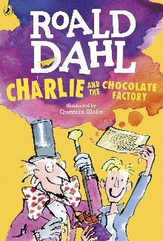
RSHE
Me & My World

We will think about ourselves, our relationships and how we fit into the wider world. We will learn about kindness, respect, feelings, safety and making positive choices.

Diary Writing
We will write a diary entry linked to the story. We will use first person, describe thoughts and feelings, and include informal language to make the writing sound personal and realistic.

Setting Description
We will describe Wonka’s world in detail using exciting vocabulary. We will use expanded noun phrases, powerful adjectives and careful punctuation to create a vivid picture for the reader.
YEAR 4
AUTUMN TERM
The Wonderful World of Chocolate

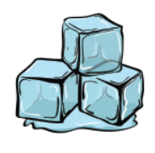

SCIENCE

States of Matter

We will investigate solids, liquids and gases and explore whether materials can change shape. We will observe what happens when materials are heated or cooled and use scientific vocabulary to describe our findings.

Living Things & Their Habitats

We will identify and classify living things found in our local area. We will ask and answer questions about habitats, look closely at different environments and find out how living things are suited to where they live.

GEOGRAPHY
My Region and Campania, Italy

We will compare our local area with Campania in Italy and find out how they are similar and different. We will explore climate, landscape, settlements and the ways people live, work and travel in each place.
DT

Food and Nutrition –
Chocolate That Cares

We will investigate how chocolate is made and think about how it can be fair for the people who grow it and kind to the planet. We will learn about ingredients, packaging and responsible food choices before designing our own chocolate product.

FRENCH
All Around Town
We will learn vocabulary for places around town, practise simple directions and use short conversations to talk about where we go.

COMPUTING
Online Safety

We will learn how to stay safe online and use technology responsibly. We will explore how to make sensible choices, protect our personal information and report anything that worries us.



MUSIC
Charanga

We will sing and perform in solo and ensemble contexts using our voices. We will listen carefully, remember sounds and develop our aural memory.

PE
We will develop our skills in football and hockey with Mr Green, and in fitness and yoga. We will practise teamwork, coordination, control, balance and stamina through active and enjoyable lessons.

