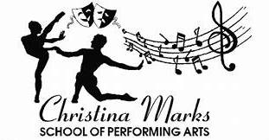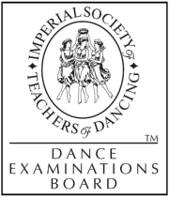

Dear Parents/Guardian,

OPEN TO ALL YEAR GROUPS.

I, Christina Marks will be offering the students of Loxwood School.

Street dance MONDAY LUNCHTIME
Musical theatre FRIDAY LUNCHTIME
Cheerleading WEDNESDAY LUNCHTIME

Class times will run from 12:20-1PM
Whether you’re looking to discover a new passion or develop your skills, our classes provide a fun and supportive environment for all levels. During this trial, you’ll get a taste of what our regular classes’ offer, with the chance to explore Dance in a vibrant and engaging way.
We can't wait to see you there and help you take your musical theatre journey to the next level!
We look forward to welcoming your child to this exciting new adventure!
To register and book please follow the link below.

https://christina-marks-sopa.classforkids.io

Any queries please do not hesitate to ask.

The ethos which lies at the heart of the school is to dream, aspire, achieve and excel.

Yours Sincerely,

Christina Marks.
Email- Christinamarksschoolofperformingarts@hotmail.com
Tel- 07525850232

