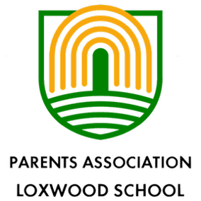

18th July 2025
Dear Parents and Carers,

We would like to warmly invite you to attend the PALS Annual Group Meeting, which will take place on:

Date: Monday 15th September 2025
Time: 7:30pm
Location: Onslow Arms, Loxwood

This annual meeting is a great opportunity to learn more about what the PTA does, hear about the achievements of the past year, and find out how you can get involved in supporting the school community.

During the meeting, we will:

- Share updates on fundraising and events
- Discuss plans for the upcoming school year
- Elect new committee members (if applicable)
- Welcome new ideas and feedback from parents
Whether you’re a regular volunteer or completely new to the committee, your presence and input are valued. The meeting will be informal and inclusive, and refreshments will be provided.

We are currently looking for a Secretary, to help ensure the sooth running off PALS. This involves preparing agendas, taking minutes and supporting keeping everyone connected.
If you are interested in joining the PALS committee or volunteering in any capacity, we’d love to hear from you at the meeting—or feel free to contact us in advance at palsloxwood@gmail.com.

We hope to see you there and look forward to working together to make this a great year for our school community!

Regards
Jasmine & Pippa

