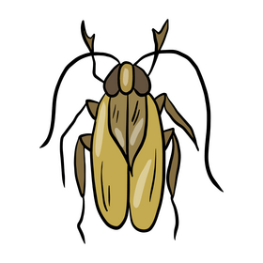Come along to Loxwood School’s first ever….

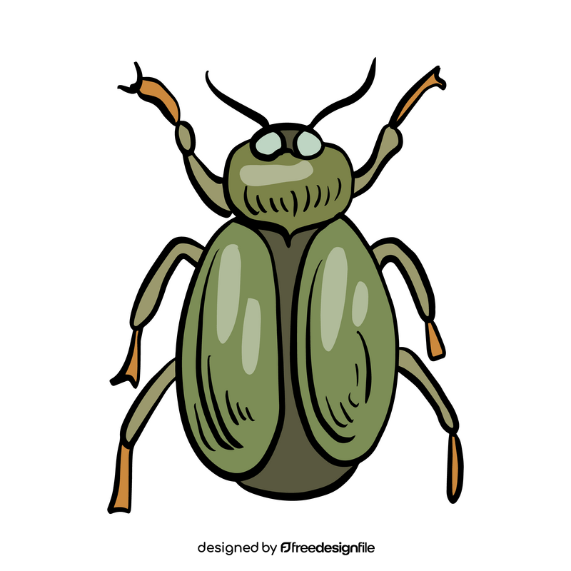**Bio-Blitz!!**

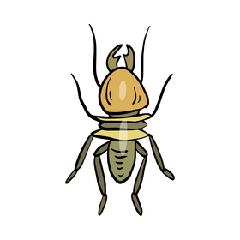When - Thursday 19th June 2025

3.15pm – 4.30 pm

Where – Our school woodland and grounds

Help us to look under logs, scour behind stones and peer though the plants, as we aim to record as many different living things as we can that are calling our woodland and school grounds home. Just come along and join in.

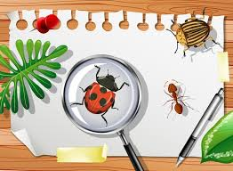

*Pre-school children and younger siblings are also welcome to join us for this event. **Please note that parents will be responsible for supervising their own children, at all times.**

*Our environment is precious, so please make sure that no living things are harmed or disturbed.

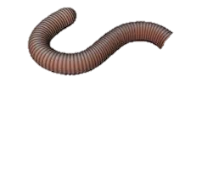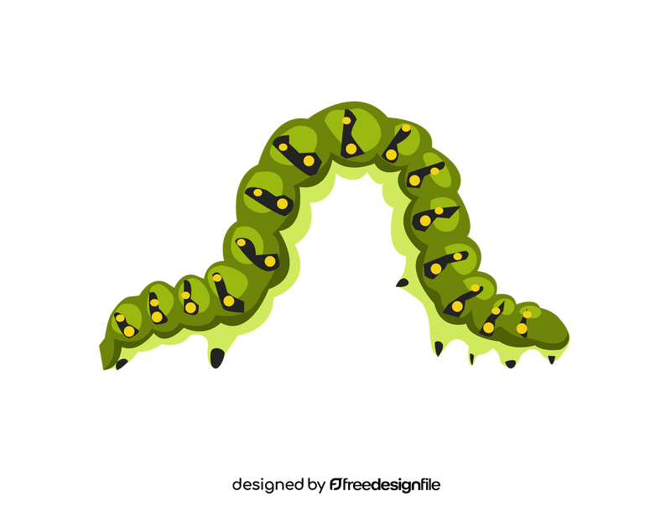*You may wish to bring wellies or trainers to wear as it can be muddy or uneven under foot.