PE Funding

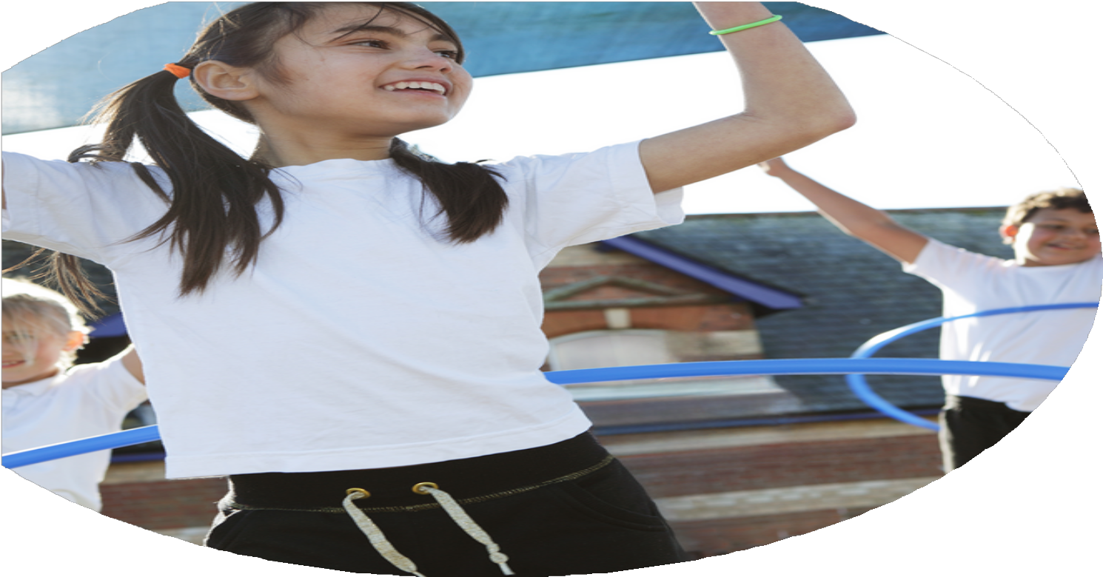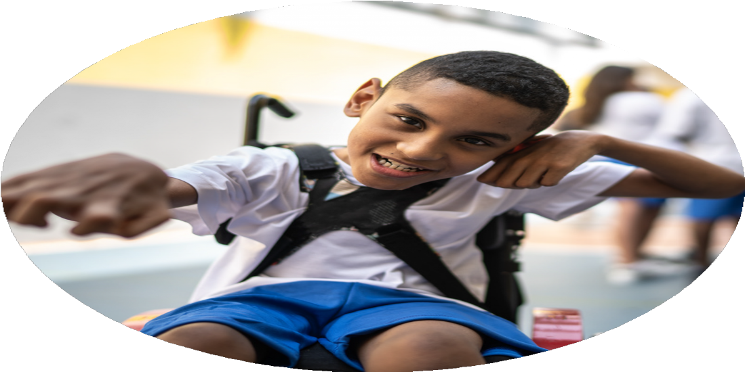

Evaluation Form

**Commissioned by**

**Created by**

Images courtesy of Youth Sport Trust

**PE Funding Evaluation Form**

 It is intended that this template should be used as preparation for the completion of the statutory digital reporting tool being introduced this academic year. You can upload data (including swimming) from this template onto this platform once it becomes accessible.

 Before you decide how you are going to use the funding for this academic year you should reflect and evaluate the impact of your use of the funding in 2023/24.

 All spending of the funding must conform with the terms outlined in the Conditions of Grant document.  The template is a working document that you can amend/update during the year.

 Based on your evaluation of last year’s funding you should decide what you intend to do this academic year, how you will do it, and what impact you expect it to have.

It is important that the funding is used effectively and based on your school’s needs.

 You must use the funding to make additional and sustainable improvements to the PE and sport in your school.  You must develop and add to the PESSPA activities that your school already offers.

*Summative digital reporting from June 2025 will continue to include swimming and water safety information therefore funding can be used to provide top-up lessons where necessary to ensure pupils meet national curriculum swimming requirements.*

Limited Participation in Early Years and KS1

* Fewer formal opportunities for Reception and Year 1 in competitive settings.
* Active lunchtimes present, but not consistent evidence of impact in EYFS.

Some Children Still Not Reaching 30 Active Minutes Outside School

* 6% of parents reported their child does not meet 30 minutes/day physical activity.
* Not all families responded to the questionnaire (25 did not reply).

Uneven Exposure to SpecialistProvision

* Specialist coaching offered mainly to Years 4–6; limited for younger year groups.

Underrepresentation in Talented Pathways

* Only 3 events for talented athletes – may not be enough to stretch more able pupils.
* No data provided on follow-up or sustained pathways beyond school level.
* **Survey Gaps** – 25 parents did not respond to the questionnaire; full picture unknown.
* **Analysis of Participation Data** – EYFS and Year 1 have fewer structured competitive opportunities.
* **Coach Distribution Records** – Clear focus on upper key stage for specialist coaching.
* **Talented Athlete Logs** – Only 3 identified events; no extended talent development pathways noted.

Participation Logs – 242 pupils involved; 96% in Level 2; all juniors in Level 1.

Parent Questionnaire – 94% engagement in out-of-school activity (85 of 110 parents responded).

Event Attendance Records – 17 events attended, with new sports added.

Pupil Voice & SEND Feedback – Used to adapt curriculum and ensure inclusivity.

Sports Leader Logs – Show consistent leadership impact during lunchtimes and events.

Social Media Metrics – UTTM, Facebook, and Instagram used to raise profile and engage families.

Teacher and Coach Reports – Positive feedback from specialist instructors (Dance, Tennis)

High Participation Across Key Stages

* All junior children took part in at least one Level 1 competition.
* 96% of juniors represented the school in Level 2 competitions – an increase from 92% last year.
* All Year 5 & 6 children competed; all juniors were selected and invited.
* A total of 242 sports participants across events, showing strong engagement.

Broadened Sporting Opportunities

* Added an extra Level 1 competition (6 sports this year instead of 5).
* Children experienced new, enriching sports: Olympic Odyssey (VR), breakdancing, freestyle football, beatboxing, and Boogie Bounce.
* Street Cricket and Dance were new events attended this year.

Access to Specialist Coaching

* Year 5 had tennis coaching in a 6-week block.
* Years 4–6 received specialist Dance instruction.

Inclusivity and Variety in Offer

* Opportunities provided across all year groups (Y1–Y6).
* Inclusive sport (SEND, KS1/KS2 Multi Skills, Alternative Sports)
* Competitive sport (Cross Country, Tag Rugby, District Sports)
* Talented athletes (3 events)
* SEND and Disadvantaged pupil voice collected and used to inform practice.

Active Leadership and Pupil Engagement

* Sports Leaders ran active lunchtimes for KS1 and supported all House competitions.
* Learning to Lead initiative embedded in PE lessons for all students.

Family & Community Engagement

* 94% of surveyed parents said their child does 30+ minutes of daily activity outside school.
* PE profile raised via Facebook, Instagram, and UTTM updates.

What are your plans for 2024/25?

Intent

How are you going to action and achieve these plans?

Implementation

**1. Increase Specialist Access for KS1 & EYFS**

* Book specialists for younger years (e.g., dance, movement).
* Timetable sessions and use team teaching for staff CPD.
* Monitor through observations and feedback.

**2. Boost Daily Physical Activity for All**

* Identify inactive pupils via surveys.
* Launch active challenges, targeted clubs, and daily routines.
* Promote activity via social media and newsletters.

**3. Maintain Inclusive & Competitive Opportunities**

* Plan a balanced events calendar (inclusive + competitive).
* Track participation data (SEND, PP, gender).
* Use staff CPD and School Games network for support.

**4. Use Pupil Voice & Parental Feedback**

* Collect termly pupil voice and annual parent surveys.
* Show “You said, we did” outcomes.
* Involve school council or ambassadors in planning.

**5. Introduce New Activities**

* Offer 2+ new activities per key stage each year.
* Use taster sessions and link to clubs.
* Monitor interest via feedback and attendance.

**Supporting Actions:**

* Termly staff CPD.
* Allocate Sports Premium for resources.
* Share updates through social media and displays.
* Strengthen links with local clubs and external providers.
* Increase access to **specialist sessions for KS1 and EYFS**.
* Explore ways to boost **daily physical activity for the remaining 6%** of children.
* Maintain the strong focus on **inclusive and competitive offers**
* Continue to use **pupil voice and parental feedback** to guide improvements.
* Increase the activity for all by introducing them to new physical activities.

What impact/intended impact/sustainability are you

expecting?

How will you know? What **evidence** do you have or

expect to have?

* **How You’ll Know:**
  + Participation data year-on-year (e.g., % involved in Level 1 and 2 competitions).
  + Growth in event participation and expansion of opportunities offered.
  + Improved confidence and enthusiasm from children.
* **Evidence:**
  + 96% Level 2 representation (↑ from 92%).
  + 242 total participants.
  + Attendance at 17 sports events.
  + Pupil voice feedback and teacher observation.
* How You’ll Know:
  + Student enjoyment and engagement in new activities.
  + Continued demand for repeat or extended sessions in future years.
* Evidence:
  + Feedback from staff, children, and visiting coaches.
  + Photos/videos and reflections shared via UTTM and social media.
  + Informal feedback and increased uptake in clubs following these experiences.
* How You’ll Know:
  + Participation data showing representation across demographics.
  + Ongoing use of pupil voice to inform provision.
* Evidence:
  + Inclusive events offered across year groups.
  + Collected SEND and disadvantaged pupil voice data.
  + Increased engagement in lessons and events by targeted

### ****1**. Increased Participation in Physical Activity and Competition**

* **Impact:** More children are engaged in physical activity during school hours and represent the school in competitive sport.
* **Intended Impact / Sustainability:**
  + Develop lifelong habits of physical activity.
  + Foster teamwork, resilience, and sportsmanship.
  + Continue to embed inclusive opportunities across all year groups.

### **2. Broader Curriculum and Enriched Experiences**

* **Impact:** Children experienced a broader range of physical activity (e.g., VR Olympics, Boogie Bounce, freestyle football).
* **Intended Impact / Sustainability:**
  + Broaden children’s physical literacy and motivation by exposing them to varied experiences.
  + Raise aspirations and curiosity around less mainstream sports

### . **3. Inclusive PE and Opportunities for All**

* **Impact:** Children of all abilities (SEND, disadvantaged, less active) had tailored access to physical activity and events.
* **Intended Impact / Sustainability:**
  + Ensure equity in PE and sports participation.
  + Embed inclusive practices across the school, not just at events.

What **impact/sustainability** have you seen?

What **evidence** do you have?

* **Evidence:** Event records, participation data, and demographic tracking
* **Evidence:** Curriculum plans, provider logs, and pupil voice feedback.
* **Evidence:** Sports event tracking, SGO engagement, and inclusion logs.
* **Evidence:** Leadership logs, pupil reflection, and teacher feedback.

**1**. High Participation & Inclusion

* Impact: 100% of junior pupils took part in Level 1 competitions; 98% in Level 2.  
  300 pupils participated overall (↑ from 242), including 49/51 disadvantaged children.
* Sus**tainability:** Inclusive selection systems are embedded; all children are invited and supported to participate.

### **2. Broadened and Engaging Curriculum**

* **Impact:** Pupils experienced new sports (e.g. Quidditch, parkour, Pok-A-Tok) and specialist coaching in dance and tennis.
* **Sustainability:** Strong links with external providers and pupil voice used to shape future offers.

. Inclusive and Competitive Opportunities

* Impact: Events covered all years (Y1–Y6) with inclusive, competitive, and talented pathways.
* Sustainability: Balanced sport calendar with consistent access for all groups.

### **. Leadership Development**

* **Impact:** Sports Leaders ran lunchtimes and House events; all pupils engaged in “Learning to Lead” in PE.
* **Sustainability:** Leadership roles are structured, ongoing, and embedded in PE lessons.

### **5. Increased Parental Engagement**

* **Impact:** 94% of parents reported their child is active outside school (↑ response rate).
* **Sustainability:** Regular updates via social media and UTTM keep parents engaged.