Sycamore Class
Autumn 2023
Digging Up the Past
You will be expected to complete two activities per half term, to a high standard! Please tick off this sheet to show which projects you have chosen.
Researchit    Choose 3 reasons why you think people from Stone Age, Bronze Age or Iron Age were great at things or not.  Food: How did people eat, was it great?  Homes: How did people shelter, was it great?  Clothes: What did they wear, were they great?  Jobs: What did they have to do every day, was it great?  Technology: Which objects made life easier, were they great?  Survival: What did they have to know to survive, was it great?  Skills - to develop a secure knowledge and understanding of changes in Britain. | Compareit  Compare two books by the same author. What similarities do they have? How are they different? Present your work as a poster.    Skills – to identify themes and conventions in a wider range of books. | Factfindit  Create a fact file on different types of rock. Find out where they are found, how they are made and what they look like.  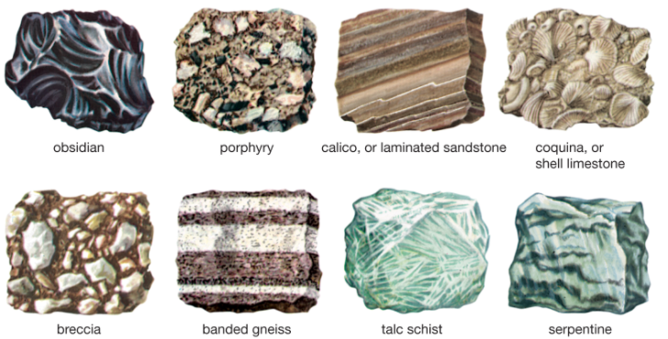  Skills – to use search technologies effectively. | Quizit  Find out about light, reflection and shadows to create a quiz for a friend or family member. You should ask between 5 and 10 questions.  Skills – to ask relevant questions; to identify how sounds are made; recognise that vibrations from sounds travel through the medium to the ear.  
Makeit  Can you make a model of Stonehenge?  You can use any materials you have at home or find outside for example, matchsticks, stones, food, clay etc.    Skills – to develop a secure knowledge and understanding of changes in Britain. | Numéroit  Can you create a French word search including the French numbers in words 1-10?  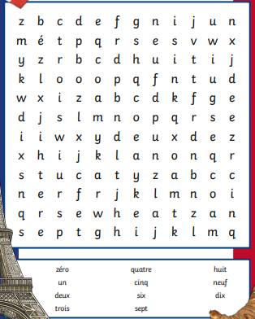  Skills – to develop a knowledge and understanding of French numbers 1-10. | Singit  Can you record yourself singing the 3, 4 or 8 Times Tables… or all three!    Skills – To enhance timetable knowledge. | Designit  Can you design a PowerPoint on how to keep safe online?    Skills – to improve skills and develop understanding of how to use a Microsoft application.
Key skills

