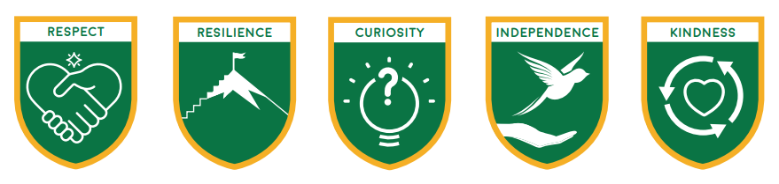

Loxwood Learners’ Code:


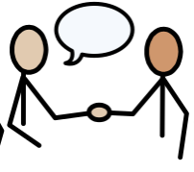
- We are kind, helpful and polite.
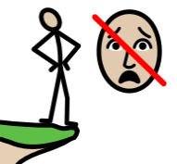

- We are brave enough to make mistakes which show resilience.
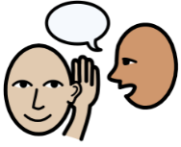
- We show respect by listening to others and taking care of our school.

- We are curious about our world and how to look after it.

- We are a good friend.
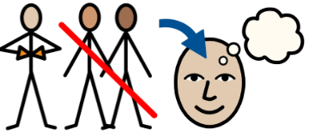
- We will show independence by taking responsibility for our learning and behaviour.

