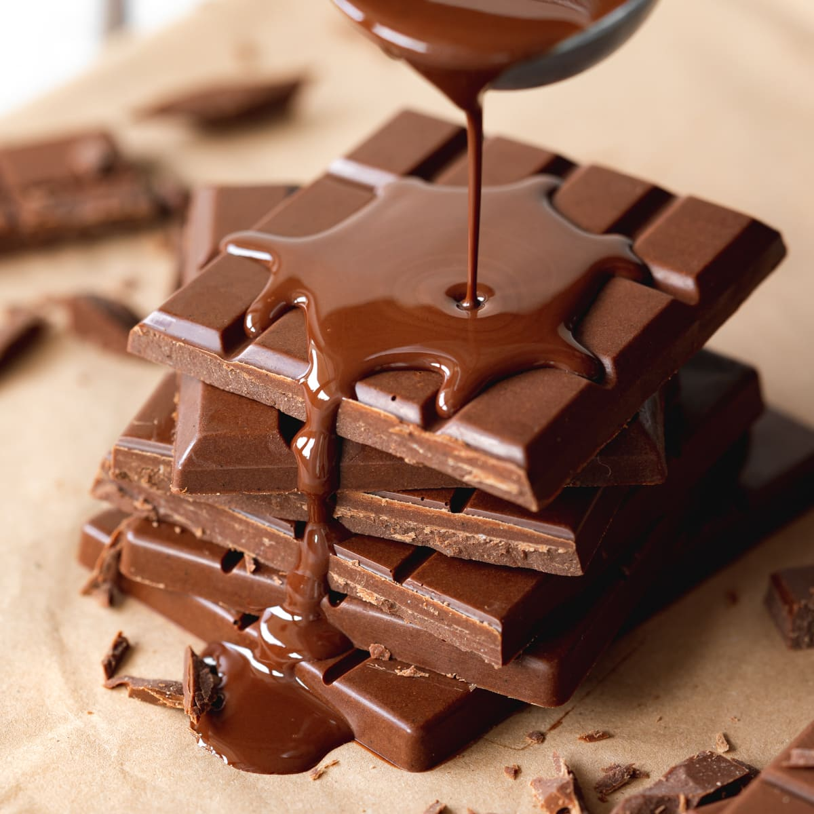  Explore the journey of chocolate.  Research how chocolate is made - from cocoa bean to chocolate bar. Draw and/or explain each stage. | 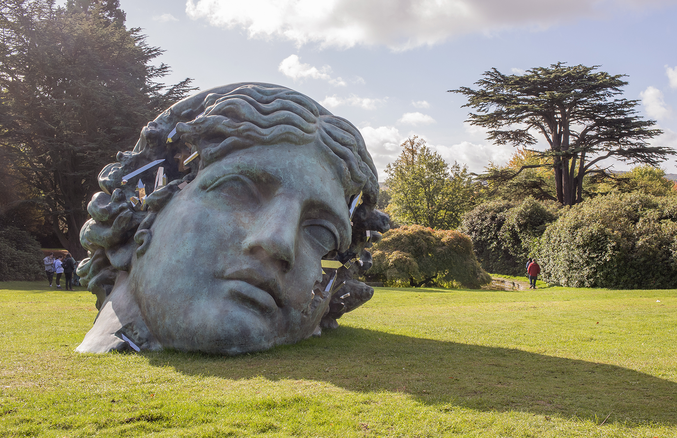  Find a sculpture near your home or somewhere you visit. Then draw or photograph it and write a few sentences describing what it’s made from. | 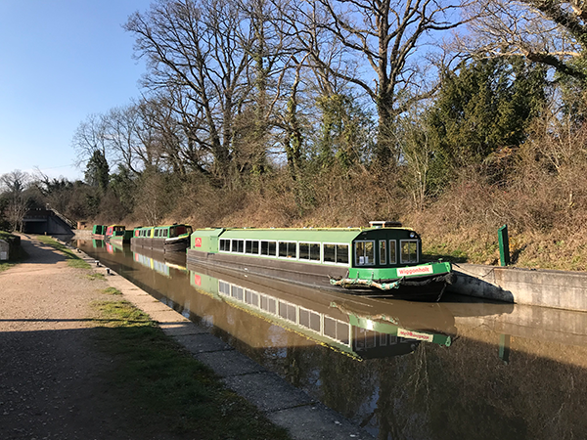  Find out about animals that live in Campania or Loxwood.  Present your findings as a mini fact file or poster.
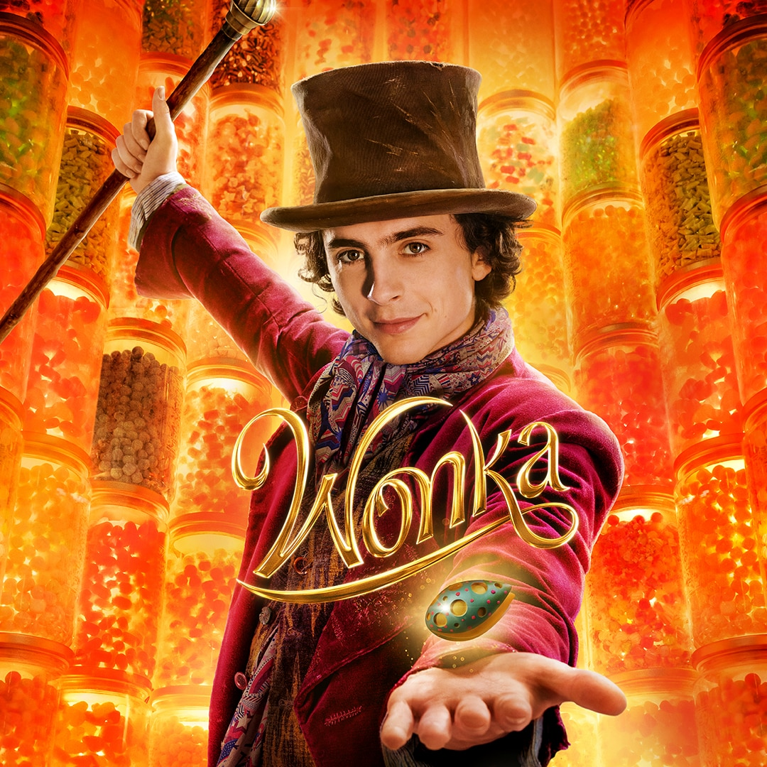  Imagine you are Wonka and create a chocolate bar advert.  Design packaging and write a short slogan. | 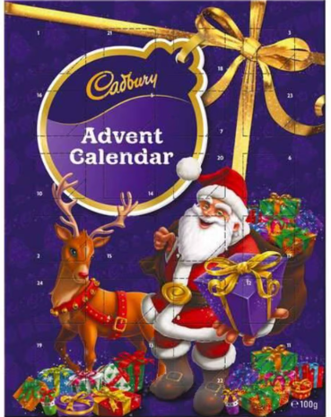  Design your own chocolate advent calendar! Draw your design and label the different features, including the chocolates, packaging and decorations, | 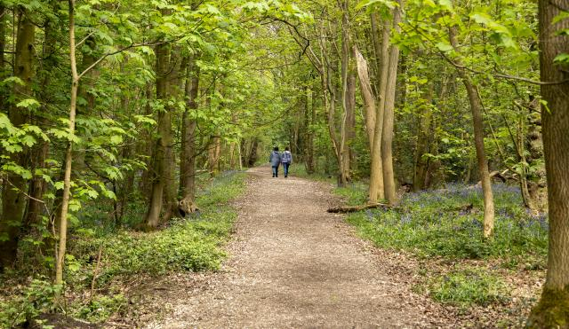  Go on a nature walk.  Take photos or make a list of 5 different living things you spot in a local habitat.
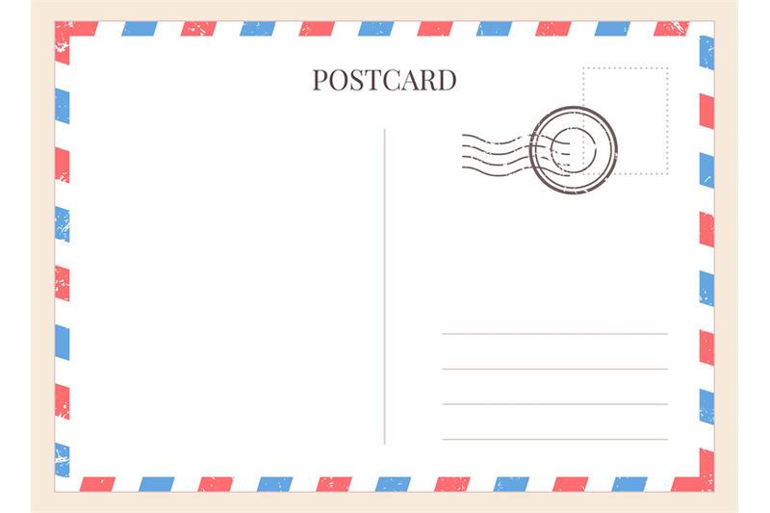  Write a postcard from Loxwood or Campania.  Describe the landscape, weather, animals, or food as if you're visiting. | 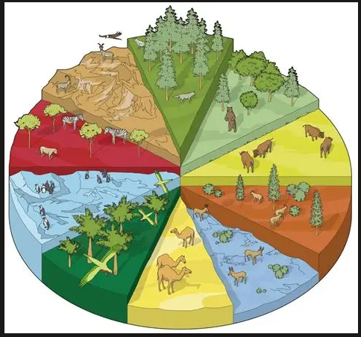  Find a living thing in your garden, local park or nearby area and investigate its habitat. Draw or photograph it and write a few sentences explaining where it lives, what it needs to survive and how it is suited to is habitat. |   Take 5 photos of yourself reading in different places.  Write a couple of sentences telling us where you are and why you are reading there.  Try to choose places linked to nature or travel.
Homework Fun for Sycamore Class Autumn 2026
Ideally we would like you to complete two of these activities each half-term which would be 4 projects to complete before the end of the summer. We will always try to celebrate homework as soon as practically possible.

