|  |
| --- |
| **Science**  **Properties and Changes in Materials**  To compare and group together everyday materials based on their properties and response to magnets; to know that some materials will dissolve in liquid to form a solution, and describe how to recover a substance from a solution. To use knowledge of solids, liquids and gases to decide how mixtures might be separated.  **Living things and their habitats**  During this unit of work, children will learn the seven life processes that distinguish living from non-living things. They will consolidate and extend previous learning on the life cycles of plants and  Animals, comparing and describing differences in the life cycles of mammals, amphibians, reptiles, birds and insects. They will learn how animals and plants reproduce by comparing differences and similarities between five different animal groups.  **Computing**  **Radio stations**  To learn how to use digital devices and software to record a podcast. Children will write scripts and record jingles to advertise their podcasts. |

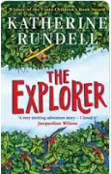

**Art**

**Rousseau**

To create sketch books to record observations and use them to review and revisit ideas. To improve mastery of art and design techniques, including drawing and painting.

**RE**

**Worship**

To explain what worship is and to make the link between worth and worship. To understand the purpose and importance of prayer. To discuss religious art and artefacts, their meanings and significance.

**PE**

**Cricket**

Athletics

**Tennis**   
Golf

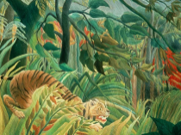

**DT**

**Moving pictures**

Having the opportunities to develop their understanding of more complex free standing structures and how they can be strengthened and reinforced. Children will gain knowledge and understanding about how to join and shape materials. Children will then apply these skills, using an iterative design process, to create their marble runs. Finally, children will test and evaluate their marble runs against design criteria.

**Maths**

**Properties of shape:**

Measuring angles in degrees; using a protractor; drawing lines and angles accurately. Calculating angles on a straight line and around a point

Triangles and quadrilaterals.

**Position and direction:**

Translation and with coordinates; symmetry; reflection and reflection with coordinates

**Decimals:** adding and subtracting decimals within 1 and crossing the whole.

Multiplying and dividing decimals by 10,100, and 1000

**Converting units:**

Kilograms and kilometre; millimetres and millilitres; metric units

**Measurement:**

Volume: comparing, measuring and estimating volume and capacity.

**English**

**Poetry**

* ‘The Tyger’ by William Blake

**Instructions**

* How to survive in the Rainforest

**Persuasive Writing**

* Leaflet writing – Adopt an animal

**Fiction**

* Setting description – The lost city

**Independent Writing**

Throughout the term, there will be increasing opportunities for independent writing.

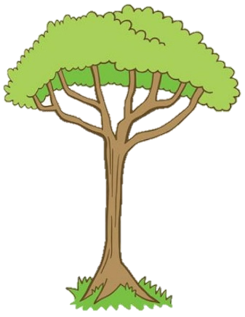

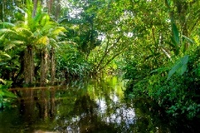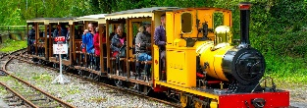

**RHE**

**Health and wellbeing**

* Safety first
* Think positive

**Geography**

**Rainforests**

The children will compare a British forest with the Amazon rainforest, and begin to explore some of the conversation issues surrounding the destruction of rainforest habitats.

**History**

**The Railways**

In this unit, children will learn about the development of the Railways in Great Britain and discover the history of the railways and significant early locomotives. Children will investigate some important historical events, such as the opening of the first passenger carrying railway lines and the Rainhill Trials and they will learn about some of the key people who were influential in the development of the railways. In addition to this, they will learn about the development of locomotive technology and examine the differences between steam, diesel and electric locomotives. The children will also learn about the growth and development of the railway network in Great Britain and use their geographical skills to map out some key routes. They will also use their speaking and listening skills to debate the positive and negative effects of the railways on different aspects of society.

**French**

**Family and friends**

To broaden their vocabulary and develop their ability to understand new words. To engage in conversations; ask and answer questions; express opinions and respond to those of others; seek clarification and help when shopping.

To look at the mysteries of tropical rainforests. From the layers of the forest and its animal inhabitants, to the unique climate found in the tropics.

YEAR 5 SUMMER TERM

***‘’The Explorer’***

**Music**

**Charanga**

To play and perform in solo and ensemble contexts, using their voices with increasing accuracy, fluency, control and expression. To improvise and compose music for a range of purposes using the interrelated dimensions of music.