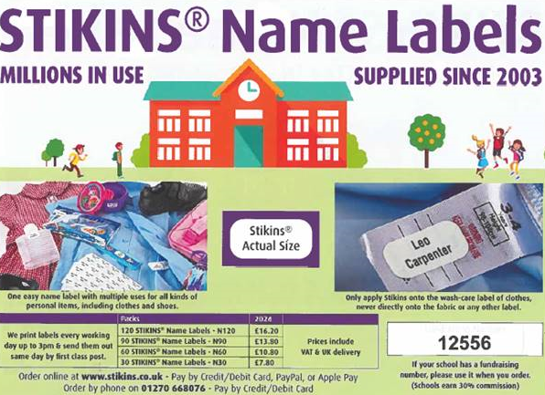

Are commission number is 12556 as above. We have so much unclaimed lost property, if you name all your childs belongings they will get returned.