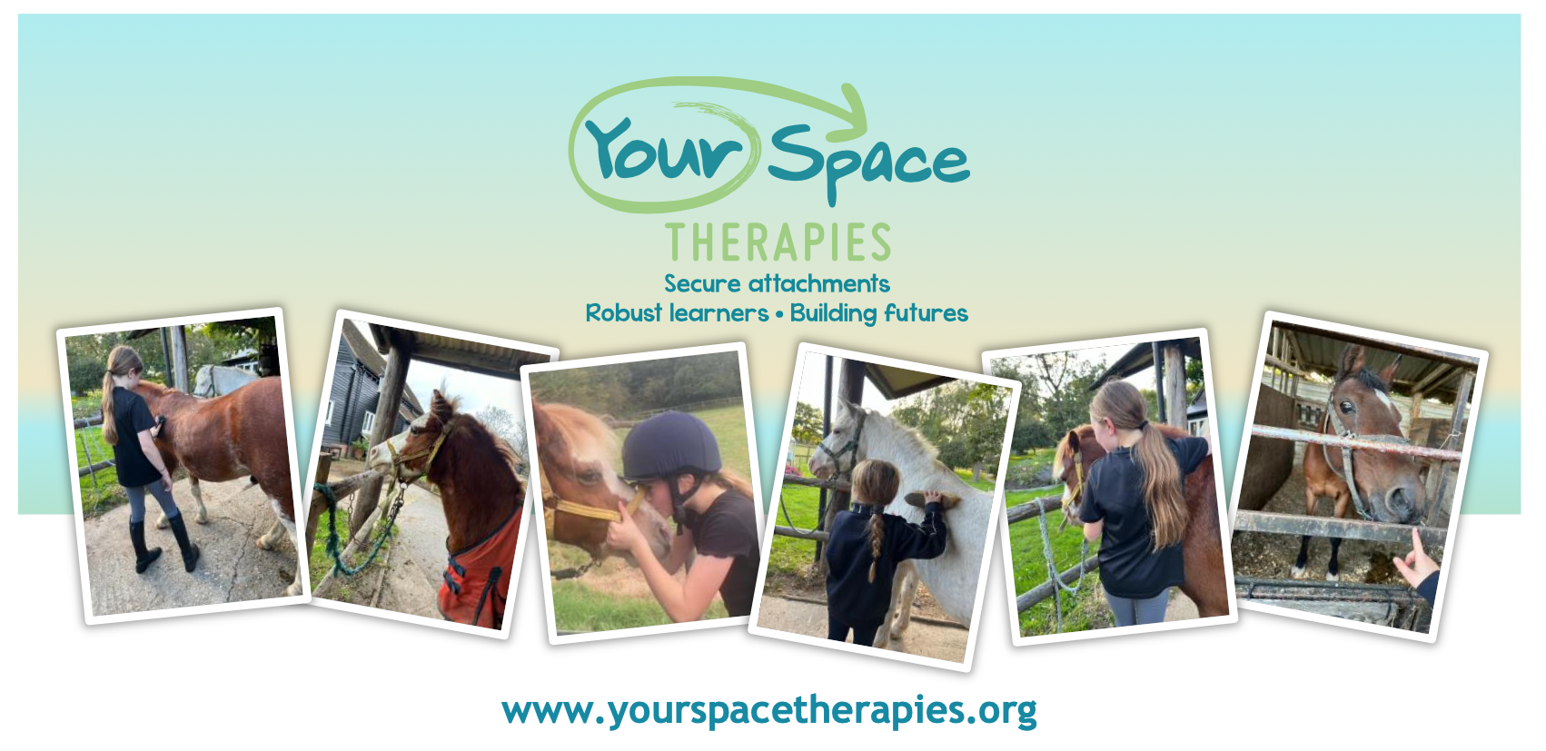
Explore Calm, Connection, and Confidence with Our Gentle Ponies!
🌼 Summer Holiday Mindfulness Pony Day’s for Kids! 🌼
Dates: Friday 8th August, Monday 11th August, Monday 18th August, Monday 1st September.
Time: 9am- 2pm
Location: Ponies ‘n’ Kids, Eaton Thorne Stables, Woodmancote, Nr Henfield, W.Sussex, BN5 9BH
Join us for a magical day designed especially for children ages 5-11! Dive into a world of peace, friendship, and mindfulness, all while experiencing the calming presence of our adorable ponies.

Your Child’s Special Day with the Ponies will include:
💖 Mindfulness Time with Ponies, Pony Care, Riding and Mounted Games and Mindful Nature Art.
Spaces are limited to 15 children per session! Please visit the Eventbrite links below now to ensure your spot. Once your booking is confirmed we will contact you to gather further information.

Friday 8th August Mindfulness Pony Day. Book now!
Monday 11th August Mindfulness Pony Day. Book now!
Monday 18th August Mindfulness pony Day. Book now!
Monday 1st September Mindfulness Pony Day. Book now!
Contact: bookings@yourspacetherapies.org
Cost: £140

Join us for an unforgettable experience that combines mindfulness and pony magic! 🐴💖

