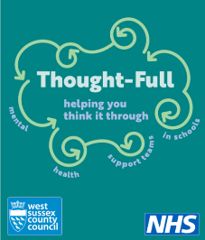
Forthcoming Parent Workshops
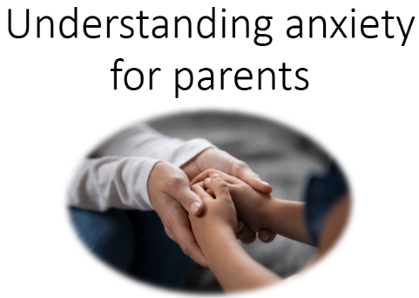

These workshops are suitable for the families of children in all year groups and we welcome family members of children who have specific difficulties with anxiety, as well as those wanting to find out more.

Broad aims of the workshops:
- To understand what anxiety is and why we feel anxious.​
- To understand the signs & behaviours of anxious feelings.​
- To think about when anxiety becomes too much for children.
- To discuss how we can change our response to help support our children.​
- To gain some strategies to use “in the moment” when your child is feeling anxious.

Workshop 1 1.45pm Friday 1st May 2026 Workshop 2 1.45pm Friday 8th May 2026
Hosted by:

St Mary’s CE (Aided) Primary, Pulborough, RH20 2AN

Commitment is to BOTH workshops please as the second builds upon the first.
Please email the school office to confirm your attendance: office@stmarysprimarypulborough.co.uk

