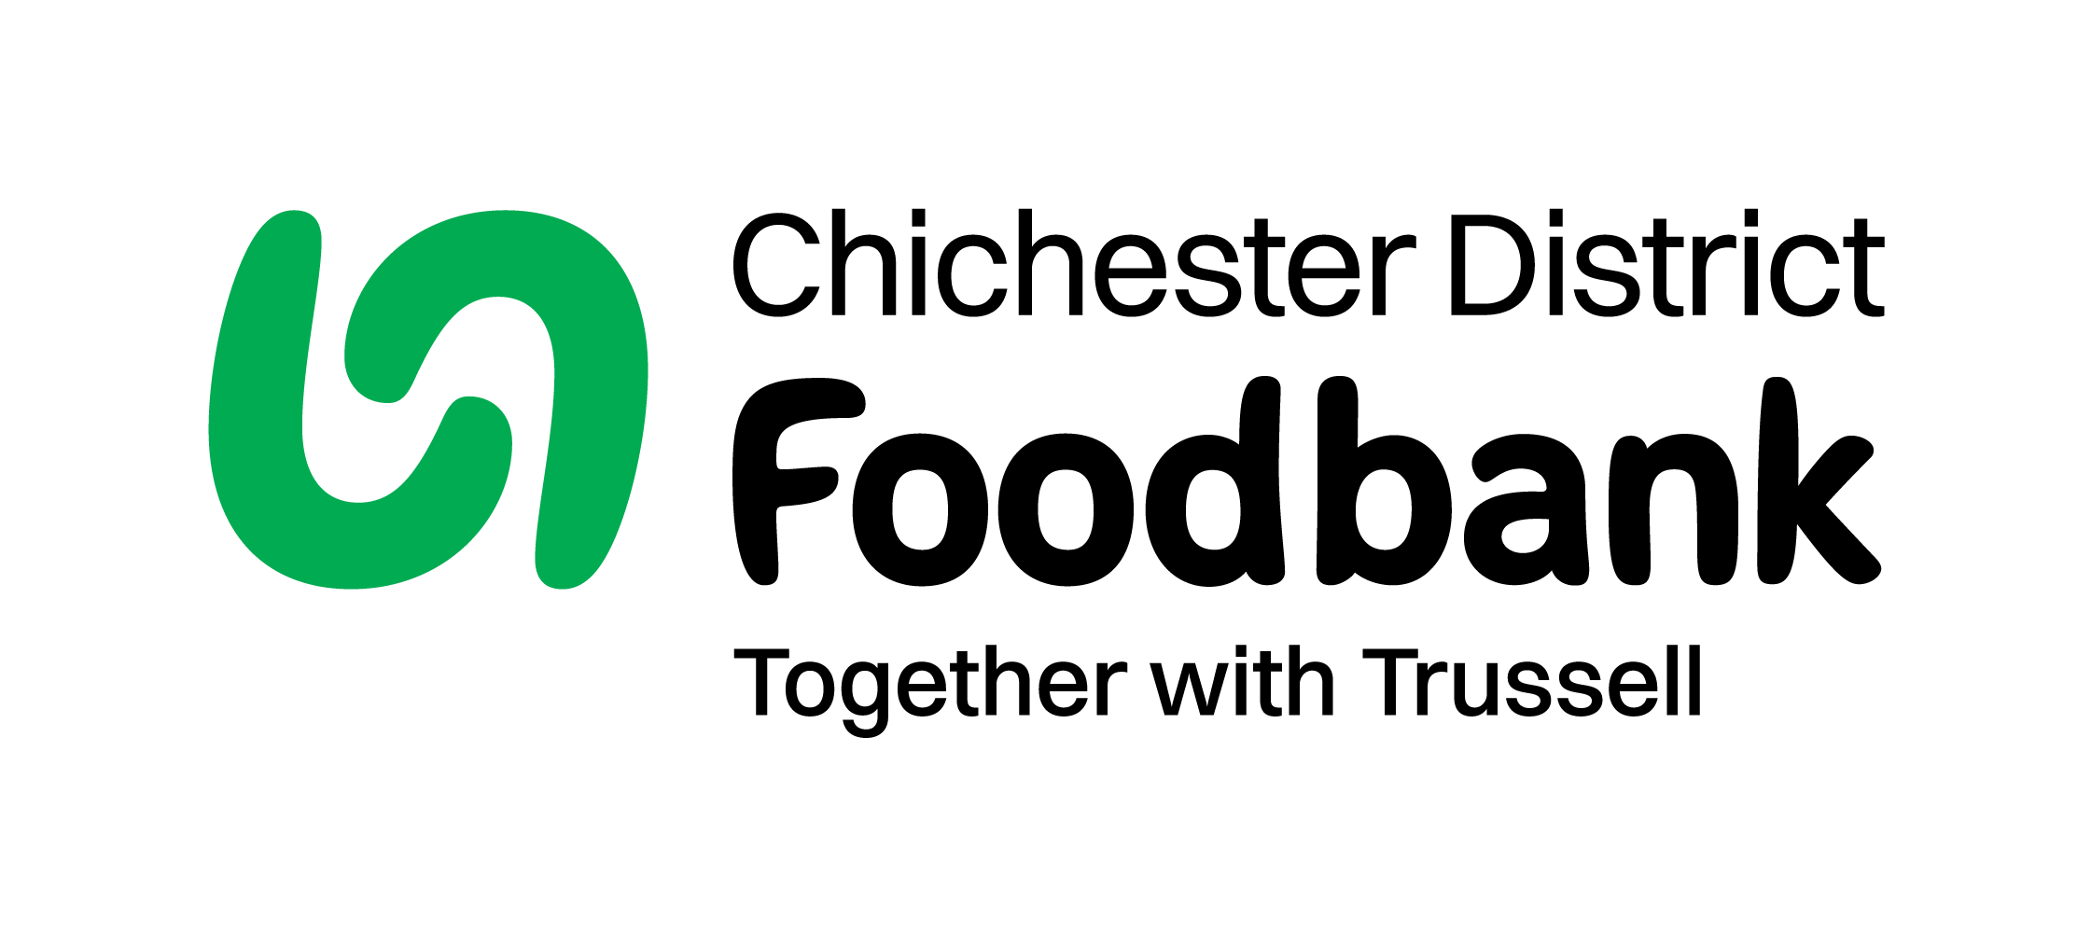 **Easter 2025 Holiday Kids Lunch Pack Scheme**

**Chichester District Foodbank**

21 Orchard Street

Chichester

West Sussex, PO19 1DD

**T** 01243 773687

**E:** kidslunchpacks@chichesterdistrict.foodbank.org.uk

www.chichesterdistrict.foodbank.org.uk

Dear Parent/Carer,

Chichester District Foodbank is continuing the “Kids Lunch Pack Scheme ” to help families whose children would have free school meals due to low income. This spring each child eligible will receive one box to help with provisions over the easter holidays.

Please register each of your school-aged children online using the link below .

You will need a voucher number created by the foodbank which will be issued from the school for each child . **(This is not the same as the term time free school meal number)**

**Your voucher number is**

Please use the following link to register: <https://chichesterdistrict.foodbank.org.uk/get-help/lunchpacks/>

**Registration opens at 9am on Saturday 1st February & closes 8pm on Sunday 9th March 2025**

**A friend, family member, or another parent can collect on your behalf.**

**Each lunch box weighs around 13 kilos …please ensure you can get this home safely.**

Collection points are:

* Monday 24th March : Swanfield Chapel, Chichester (8:30 am – midday)
* Tuesday 25th March : St John’s Church, Southbourne (8:30 am – midday)
* Wednesday 26th March : (08:30-10:30 am) Donnington, Parish Hall
* Wednesday 26th March : URC East Witterings (2pm – 4.00pm)
* Thursday 27th March : St Andrew’s Church, Tangmere (8:30 am – 11.00am)
* Friday 28th March : Chichester Baptist Church, Parklands, Chichester (8:30 am – midday)
* Friday 28th March & 4th April : Methodist Church, Selsey (9:30 am – 12.00pm)

North of the district delivery dates : ( will receive a text 48 hours beforehand to confirm delivery)

* Petworth deliveries will be made the week commencing Monday 31st March
* Midhurst deliveries will be made the week commencing Monday 24th March

If you have any issues with collecting or need any more information, please contact our office on 0776 591 5357.

Many Thanks **Marie Wallace**. Charity No: 1110522 Reg. Ltd Co. No. 5434524 Reg. in England and Wales