**100 Books To Read In Year 3 and 4**

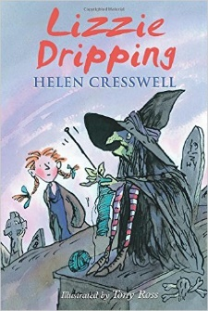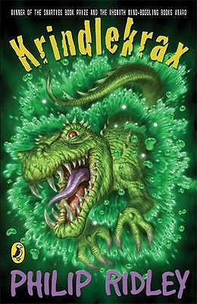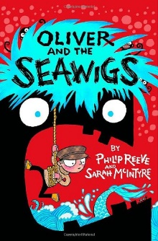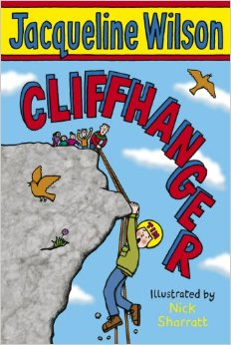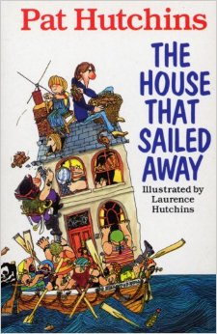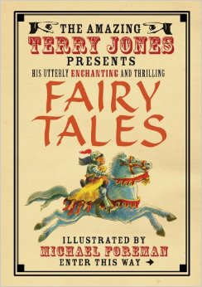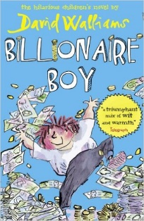

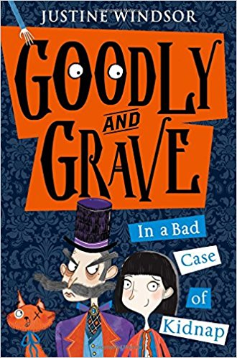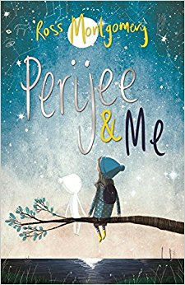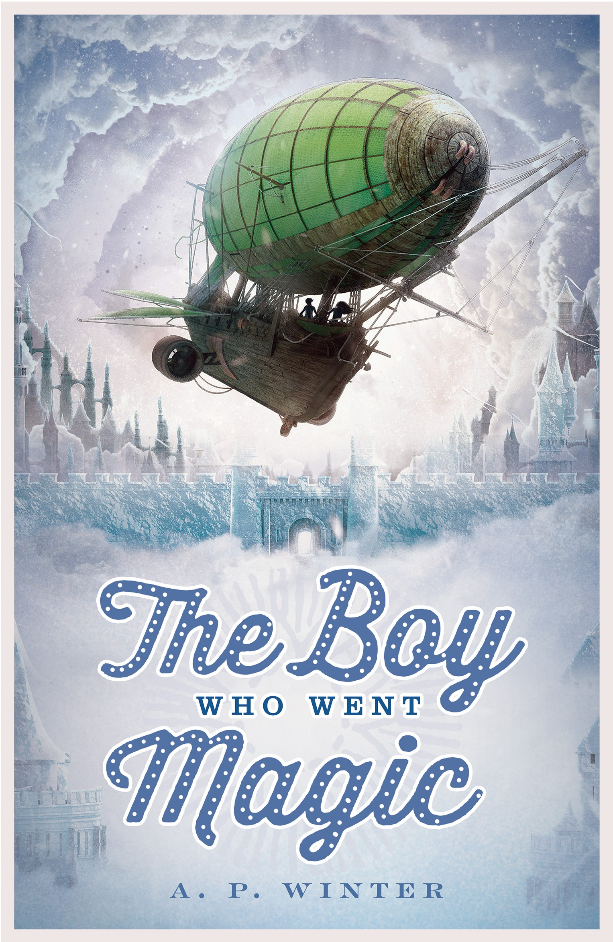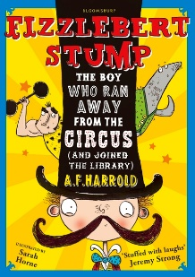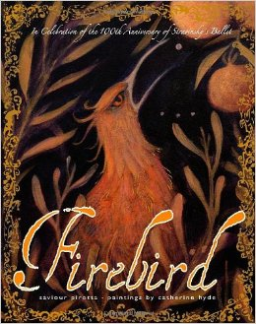 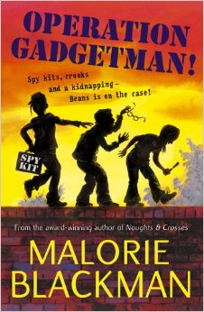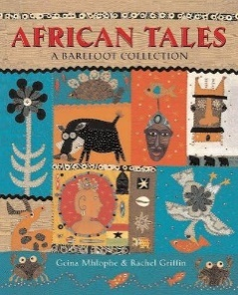 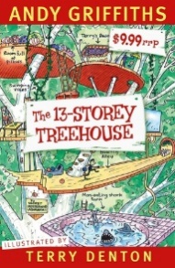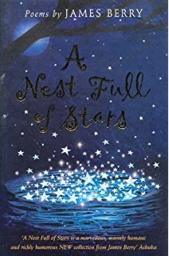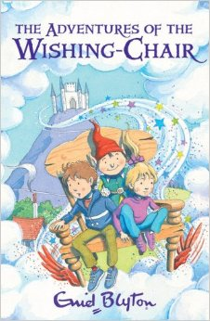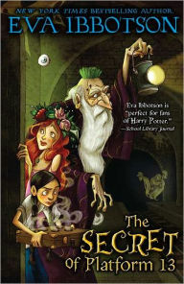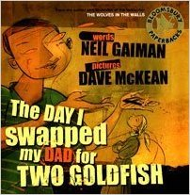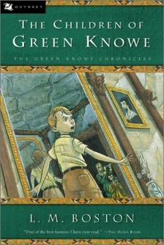

The Adventures of the Wishing-Chair

Enid Blyton

The Imaginary

A F Harold

Firebird

Saviour Pirotta

The Boy Who Went Magic

AP Winters

Operation Gadgetman!

Malorie Blackman

Belonging

Jeannie Baker

African Tales: A Barefoot Collection

GcinaMlophe

Goodly and Grave

Justine Windsor

The House That Sailed Away

Pat Hutchins

The 13-Storey Treehouse

Andry Griffiths

Perijee and Me

Ross Montgomery

A Nest Full of Stars

James Berry

The Secret of Platform 13

Eva Ibbotson

The Day I Swapped My Dad for Two Goldfish

Neiil Gaiman

The Children of Green Knowe

L.M.Boston

Lizzie Dripping

Helen Cresswel

Krindlekrax

Philip Ridley

Oliver and the Seawigs

Phillip Reeve

Cliffhanger

Jacqueline Wilson

Fairy Tales

Terry Jones

Billionaire Boy

David Walliams