**Year 3 Group B**

**Summer 1**

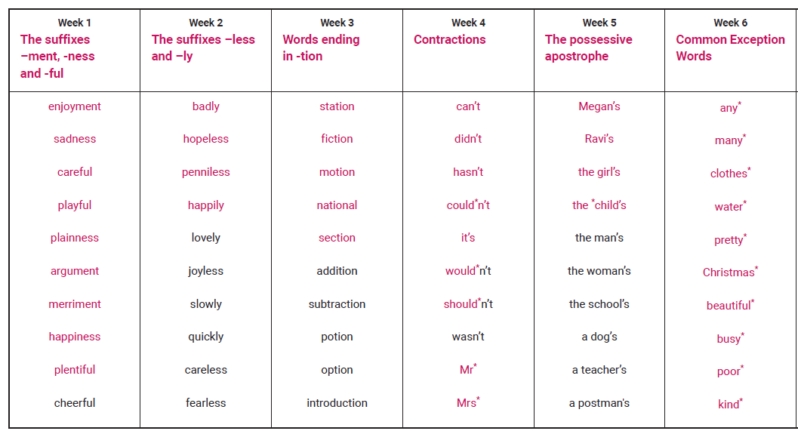

**Year 3 Group B**

**Summer 2**

