Loxwood Primary School Withdrawal from Learning Application: For Exceptional Circumstances

Did you know that across the year there are just 190 school days? That means there are already 175 days set aside for weekends, holidays, family visits and rewarding days out. We believe every school day counts to give your child the greatest opportunity of attaining a good education and to support a happy and healthy future.

The law entitles every child of compulsory school age to an efficient, full-time education. It is the legal responsibility of every parent to ensure their child attends school regularly. This means their child must attend every day that the school is open, except in a small number of allowable circumstances such as being too ill to attend or being given permission for an absence in advance from the school.

We will follow the WSCC guidelines on issuing Fixed Penalty Notices (FPN) for unauthorised absence, i.e. issue a Fixed Penalty Notice (FPN) if a child accrues 10 or more unauthorised absences in a 10-week period (each half day counts as one absence),
∙ by non-attendance at school
∙ by arriving persistently late at school (after registration has closed)
∙ by parents/carers taking their child on an unauthorised holiday during the school term.

If the Council offer you a Fixed Penalty Notice, it is £160 and should be paid within 28 days. In some instances, you may be given the opportunity to pay at a lower rate of £80 in the first 21 days. Details on the amounts payable and payment periods will be clear in the FPN. If a FPN is unpaid at the end of the 28 day period, you may be prosecuted for the offence contrary to s444 of the Education Act 1996.
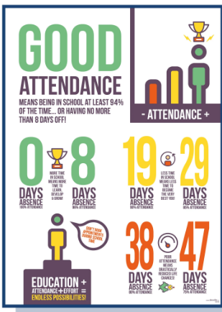

To be completed by parent/carer:

Child’s Name………………………………………………………………………. Class …………………………… Current Attendance ………….

Child’s Name………………………………………………………………………. Class …………………………… Current Attendance ………….

Child’s Name………………………………………………………………………. Class …………………………… Current Attendance ………….

Date of withdrawal from learning ……………………………………. Date of return to learning ..……………………………………...

Total number of learning days that will be missed …………

Reason withdrawal from learning is requested:
Religious observance.
Extreme family emergency – for example bereavement.
Please detail here any other reason for absence:

Name of Parent/Carer ....................................................................................................................................

Signed:................................................................................. Date: ....................................................

Headteacher decision:

Authorised: Your request has been authorised

 Unauthorised: Your request has been unauthorised

Headteacher signature …………………………………………………………………. Date: ………………………………………………………………

Other…………………………………………………………………………………………………………………………………………………………………………

………………………………………………………………………………………………………………………………………………………………………………….

