Simple sentence – a main clause (Batman)
The cow jumped over the gate.

Compound sentence - two independent clauses joined with a coordinating conjunction (FANBOY) or a semi-colon (Batman + Batman)
I drink green tea but they drink coffee.
Thomas ate spaghetti; he loves it.

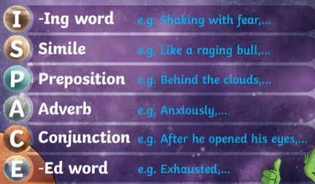
Fronted adverbial - additional information to start followed by a Batman
Additional information can be added in a variety of ways. Use ISPACE openers to help (see picture).
As soon as she could, Bella came to school.

Complex sentence – contains a subordinate clause (Batman and Robin).
Even though it was getting dark, Lola wanted to go for a walk.
Year 6 wanted to go out for PE even though they were running out of time.

Relative clause - used to give additional information about a noun. They are introduced by a relative pronoun like 'that', 'which', 'who', 'whose
Charley, who didn’t like the dark, stayed at home.

Parenthesis - is adding extra information to a sentence using brackets, dashes or commas.
The young boy, who had brown hair, went to bed.
Harry Swart (last year's losing finalist) is expected to win this heat.

Direct speech
As we were going outside, Miss Price reminded us, “Put your coat on!”
“Don’t be stupid,” shouted Edward as he ran down the stairs.
“Hurry up,” nagged Mum, “We are running late!”
The old cranky neighbour yelled, “Stop banging on the wall,” as he started holding his head in pain.

Simple sentence – a main clause (Batman)
The cow jumped over the gate.

Compound sentence - two independent clauses joined with a coordinating conjunction (FANBOY) or a semi-colon (Batman + Batman)
I drink green tea but they drink coffee.
Thomas ate spaghetti; he loves it.
Fronted adverbial - additional information to start followed by a Batman
Additional information can be added in a variety of ways. Use ISPACE openers to help (see picture).
As soon as she could, Bella came to school.

Complex sentence – contains a subordinate clause (Batman and Robin).
Even though it was getting dark, Lola wanted to go for a walk.
Year 6 wanted to go out for PE even though they were running out of time.

Relative clause - used to give additional information about a noun. They are introduced by a relative pronoun like 'that', 'which', 'who', 'whose
Charley, who didn’t like the dark, stayed at home.

Parenthesis - is adding extra information to a sentence using brackets, dashes or commas.
The young boy, who had brown hair, went to bed.
Harry Swart (last year's losing finalist) is expected to win this heat.

Direct speech
As we were going outside, Miss Price reminded us, “Put your coat on!”
“Don’t be stupid,” shouted Edward as he ran down the stairs.
“Hurry up,” nagged Mum, “We are running late!”
The old cranky neighbour yelled, “Stop banging on the wall,” as he started holding his head in pain.

