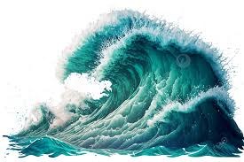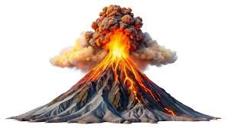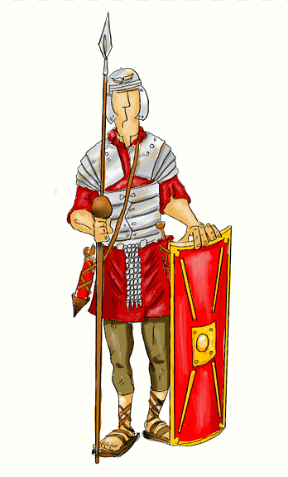**Rowan Class Spring Term Homework 2025**

**Extreme Earth**

Our learning this term will be about the Romans and Natural Disasters!

These activities are designed to develop your learning outside of school, you are expected to complete two activities per half term! We are really looking forward to you sharing with the rest of the class all the interesting information you have learnt and the skills you have developed whilst you have done it, enjoy.

|  |  |  |  |
| --- | --- | --- | --- |
| Research the skeletons of 3 animals of your choice.    All animals have different skeletons. **Can you research the skeletons of 3 different animals?** Bring them into school and see if we can guess the animals you have chosen. | Research volcanoes and make your own model volcano.  We will be learning about different types of natural disasters.  **Can you research the different layers of a volcano, perhaps you could make your own model or drawing to show these?** | Research a famous scientist and their discovery of forces, magnets or animals.  In science this term, we will be learning about animals including humans, magnets and forces.  **Can you research a key scientist who had an impact on these scientific areas?** | Read a book and draw a poster that advertises it to other children.  Have you got a recent book that you have read that you really enjoyed? **Can you make a poster to share this with other children?** |
| Research The Ring of Fire.  Earthquakes happen all over the world. **Can you research The Ring of Fire and why this is area is prone to earthquakes?** | Make a times table game that you can play with a friend.  We have started looking at our 3s, 4s and 8 timetables.  **Can you create a game to help a friend learn these?** | Create an ‘All about me’ profile in French.  In French, we will be learning how to describe ourselves.  **Can you create a profile page describing yourself?** | Create a timeline of the Roman Empire.  In History, we will be learning all about the Romans. It is important that you understand the key events. **Can you create a timeline showing the different events of the Roman Empire?** |