14th January 2025

Dear Families,

**Bromcom – My Child At School App**

As we already use Bromcom in school as our Management Information System (MIS) provider, we aim to utilise more of its functions to reduce the number of systems in operation. Consequently, we are excited to announce the rollout of the ‘My Child At School’ (MCAS) app, which you may already recognise if you have children in the secondary phase at The Weald.

MCAS is a complimentary portal that allows parents to access key information about their child in real time, either via a web browser or the mobile app. This platform features multiple modules, granting exclusive access to essential details such as academic dates, attendance records, and personal information held by the school.

At a later date, we will include modules for student reports and parents' evenings. We appreciate your continued support as we enhance communication and partnership in your child’s education.

Please make sure you check that all the contact information is up to date (ensuring we have at least two contacts per child). Please also check that the ‘Parental Consents’ are correct.

**How to access MCAS** - **New MCAS Accounts**

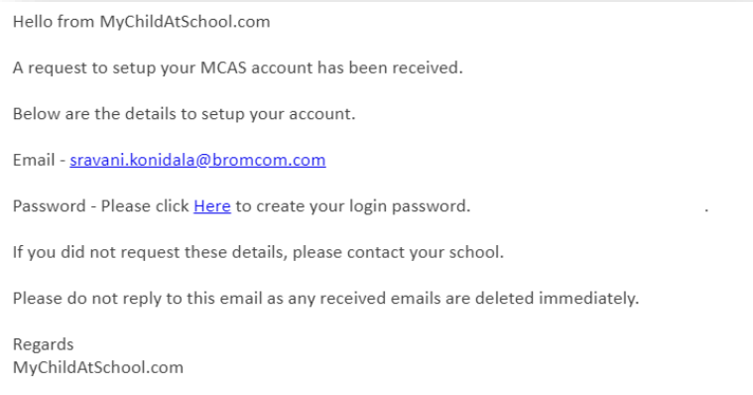For new accounts you will receive an email to the address we have on our school MIS system, with a link to set up your password to access MCAS. The email will look like this example:

To create your password for the portal, follow the link. Once this has been set up, to access the MCAS portal you will use your email address and your newly created password.

Once your account has been created, there are two ways to access MCAS.

1. You use a web browser on a computer/laptop. <http://www.mychildatschool.com/>
2. You can download the free MCAS app on your mobile device. It is available via your devices app store searching MyChildatSchool, and the app works on all iOS and Android mobile phones.

If you do not receive an email and it has not landed in your junk folder, please email reception [messages@loxwoodschool.com](mailto:messages@loxwoodschool.com) .

**Existing Accounts**

If you already have an MCAS account please continue to login with your email address and password via <http://www.mychildatschool.com/> or via the mobile phone app.

A full support guide for MCAS parent portal can be found using [this link](https://d3kchveacp7yrb.cloudfront.net/2023/07/MCAS-Parent-Guide-July-23-android-added.pdf).

Parents are encouraged to set up the app on their mobile devices after the initial setup process outlined above. Having the app will allow us to send notifications about your child to your mobile phone.

Should you have any technical issues relating to MCAS please email [messages@loxwoodschool.com](mailto:messages@loxwoodschool.com) stating your name and contact information along with your issue and we will look into a resolution for you.

Kind Regards

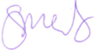

Mrs Sharon Mellors

Head teacher

