**Year 3 Group C**

**Summer 1**

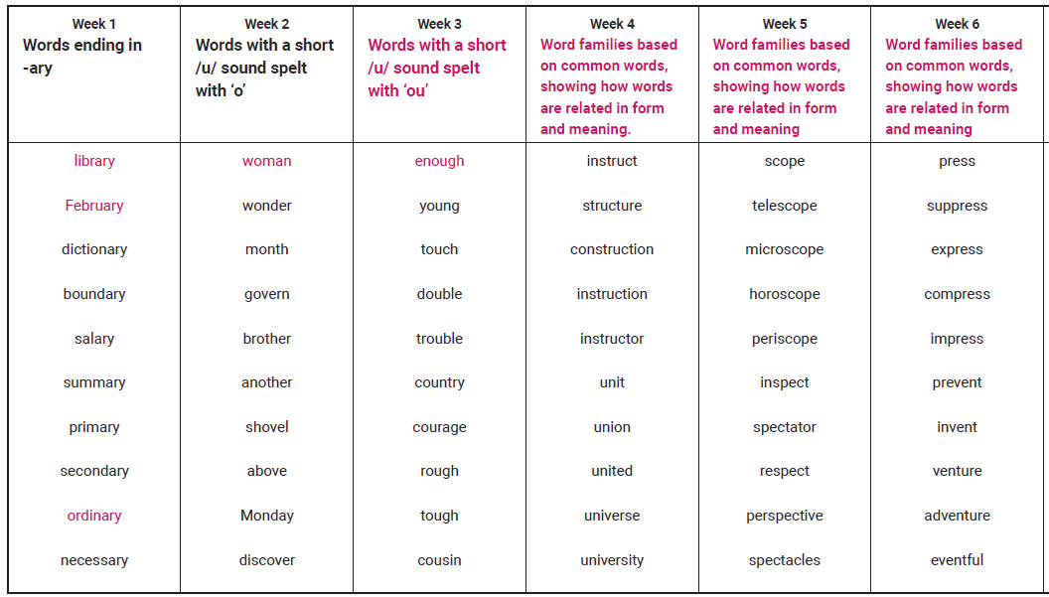

**Year 3 Group C**

**Summer 2**

