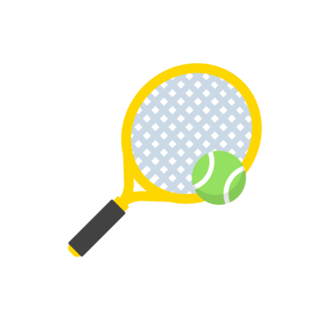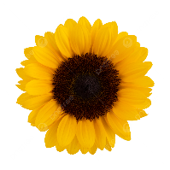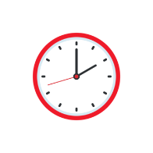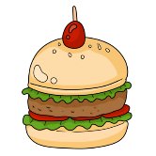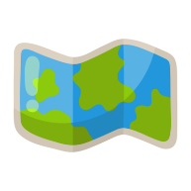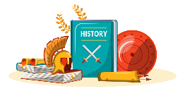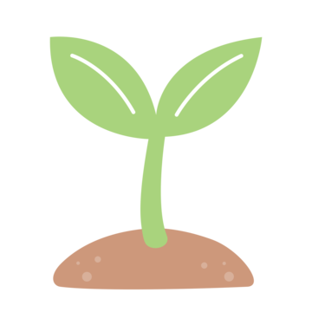

**Let It Grow**

Maths

**Mass and Capacity**

We will further develop our knowledge of measurements looking at mass (kg/g) as well as volume and capacity (l/ml).

**Fractions**

We will learn how to add and subtract fractions and find fractions of an amount.

**Measurement**

We will focus on counting money and telling the time.

**Shape**

We will be looking at properties of shapes including their lines and angles.

**Statistics**

RE

We will be exploring Buddhism. We will understand the key aspects of the Buddhist faith, finding out where Buddhism originated and looking at the special places and festivals linked to Buddhism.

**Art**

We will be using pencil, colour, Hapa Zome printing, sculpture and paper modelling to explore a range of natural materials to create different pieces of artwork.

**D&T**

We will be applying different skills to research, design and make a hand puppet using sewing skills.

French

We will develop our knowledge of French. Learning the vocabulary for a range of food, expressing likes and dislikes and learning how to count and use plural nouns.

RSHE

We will be building on our knowledge of comfortable and uncomfortable feelings. We will be focusing on managing difficult emotions and developing a growth mindset.

History

Learning all about the history of Loxwood, we will take the time to research the local area and key historical buildings. We will develop an understanding of how Loxwood has changed over time and what has stayed the same.

Geography

We will be taking the time to look carefully at the places around us and the patterns in land use. We will begin by making sketch maps whilst using symbols and keys. Learning different ways of presenting, analysing and evaluating data that is collected about our local area.

PE

Throughout the Summer Term we will be developing our skills in these areas:

**Cricket, Athletics and Tennis.**

.

Computing

We will be developing our graphic and presentation skills on the computer. We will learn to draw, order, group and manipulate objects to make a picture allowing us to combine this with text.

English

**Key Texts**

We will be reading a variety of fiction books, as well as non-fiction books and poetry.

**Writing**

We will be looking at writing similar to what we are planning to write. We will then understand and learn about the structure, vocabulary and grammar and use this in our own writing. We will be proof-reading our work to make improvements. This term we will be writing a biography about a key historical figure, a persuasive advert and a non-chronological report.

Science

**Forces and Magnets**

We will explore how the texture of an object or the surface can affect its movement. We will explore different magnets and looking at how they can pull (attract) and push (repel) at a distance without contact.

**Plants**

We will be developing our knowledge of plants, identifying and describing the functions of different parts of plants, whilst exploring what plants need for life and growth.

**Year 3 Summer Term 2025**