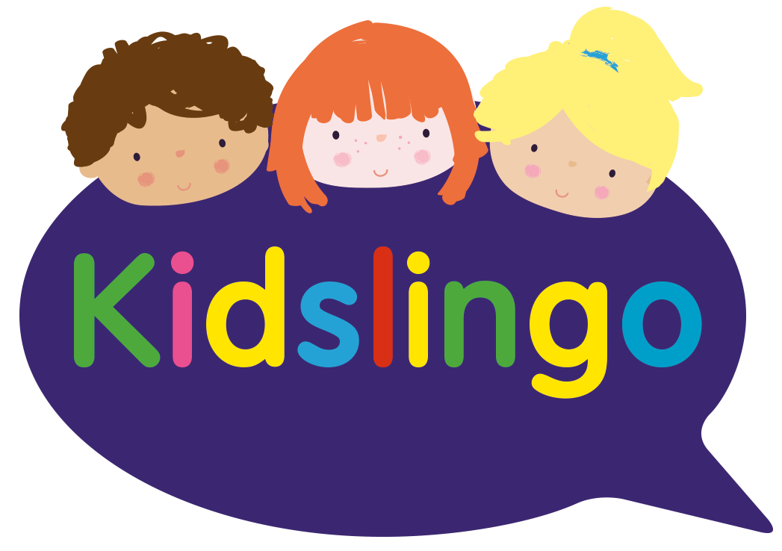

**Kidslingo Lunch Time French Clubs at Loxwood - Give your child a super power with another language!**

Kidslingo will continue to run its popular lunchtime French clubs for all children in September (subject to final numbers). We have spaces available in both our KS1 (plus Reception) and KS2 classes which run during lunch break every Wednesday.

Kidslingo is a multi award-winning language franchise, delivered by qualified Primary school teacher and language specialist Charmaine Davis who teaches at several schools in the Horsham area.

One of the leading children’s language activity providers in the UK, Kidslingo aims is to inspire young children to love languages from the very start of their language learning journeys. Working with schools, nurseries, in community venues, private homes and online, Kidslingo is a passionate believer in exposing children to languages from a young age.

Classes offer quality, fun-filled language learning taught through music, movement, singing, signs, story-telling, role play and so much more. In addition, all classes are developed to be fully aligned to the National Curriculum Languages Programmes of Study.

As well as regularly winning many awards including the What’s On 4 Kids Awards, UK’s Most Loved Creative or Academic Activity, Kidslingo are proud members of, and 5 star gold accredited by, the Children’s Activities Association which promotes high standards in children’s classes across the UK. Kidslingo were the first kids’ language franchise to achieve 5-star goldaccreditation and continue to be an active member.

Learning a new language provides young children with a wealth of cognitive, social, and emotional benefits that contribute to their overall mental health and well-being.

Each half hour session costs £7.50 per week per child payable in advance for a half-term block of 5-7 weeks. Separate classes are held for children in KS2 and KS1 & Reception to ensure teaching is age appropriate and engaging.

To book, **new** customers should use the following links or email [Charmaine.davis@kidslingo.co.uk](mailto:Charmaine.davis@kidslingo.co.uk) or text 07785 323437 for more information or visit our website [French Classes Horsham & Haywards Heath - Kidslingo](https://www.kidslingo.co.uk/area/french-classes-horsham-haywards-heath/).

KS1 & Reception

<https://www.thinksmartsoftwareuk.com/ocr/lesson_booking.php?t=ohXLDiJo1tKwICX8uGpBRg%3D%3D&u=L3qDl8J7MABeE59obquzZQ%3D%3D&p_id=8&c=447>

KS2

<https://www.thinksmartsoftwareuk.com/ocr/lesson_booking.php?t=ohXLDiJo1tKwICX8uGpBRg%3D%3D&u=L3qDl8J7MABeE59obquzZQ%3D%3D&p_id=8&c=446>

