Y5 Independent Homework Grid  ‘The Explorer’ | Knowing | Understanding | Applying | Analysing | Creating | Evaluating
Verbal  I enjoy reading, writing and speaking | Research the 5 busiest train stations in the world and create a fact file on them. | Find out how a railway station of your choice has changed over the years. Present your findings to the class. | Make a list of the items you would need for a 3-day hike in the Rainforest. Your bag should weigh no more than 10kg. You do not need to take water. | Get two different non-fiction books about railways from the library. Write a detailed book review of each one, explaining what you learnt and how the layout helped you to understand the information. | Write a native folklore story explaining how the frog got its brilliantly bright colours. The title should be ‘How the Dart Frog got its Colour’. | Create (a minimum of) 3 diary entries describing your time hiking through the rainforest. What did you see? What memories stuck with you? How were you feeling? Did you meet anyone? Did you struggle without home comforts?
Mathematical  I enjoy working with numbers and sequences |   Plot a bar graph showing the lengths of five rivers in the UK. | Make your own map of rivers in the UK. Take care to draw accurately and label each river neatly. | Research statistics of a range of different rivers (e.g. length, number of countries it travels through, maximum width) and make into a set of top trumps cards. | Plan and work out the cost for a family holiday to Brazil.  Think about:  • Journey and transport  • Accommodation  • Food  • Excursions and visits | Create a vibrant (colourful, exciting) fact file about a rainforest. It should contain facts and information, pictures, a heading and subheadings | Using your knowledge of how we can live in a more environmentally friendly way, survey friends and family to find out what they are doing. Make suggestions on how to improve.
Visual/Spatial  I enjoy painting and drawing | Draw pictures to show some of the ways in which indigenous people may use the Amazon River and rainforest. | Use a photograph of a rainforest to inspire a collage. Choose one medium for the collage (e.g. tissue, fabric, wool). | Design and annotate a new animal which could live in the rainforest. Think carefully about how it has adapted to its habitat. | Draw a map which shows train lines. | 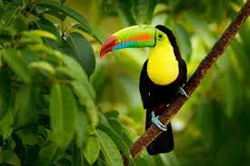  Create a picture of an animal that lives in the rainforest using a technique or materials of your choice. | 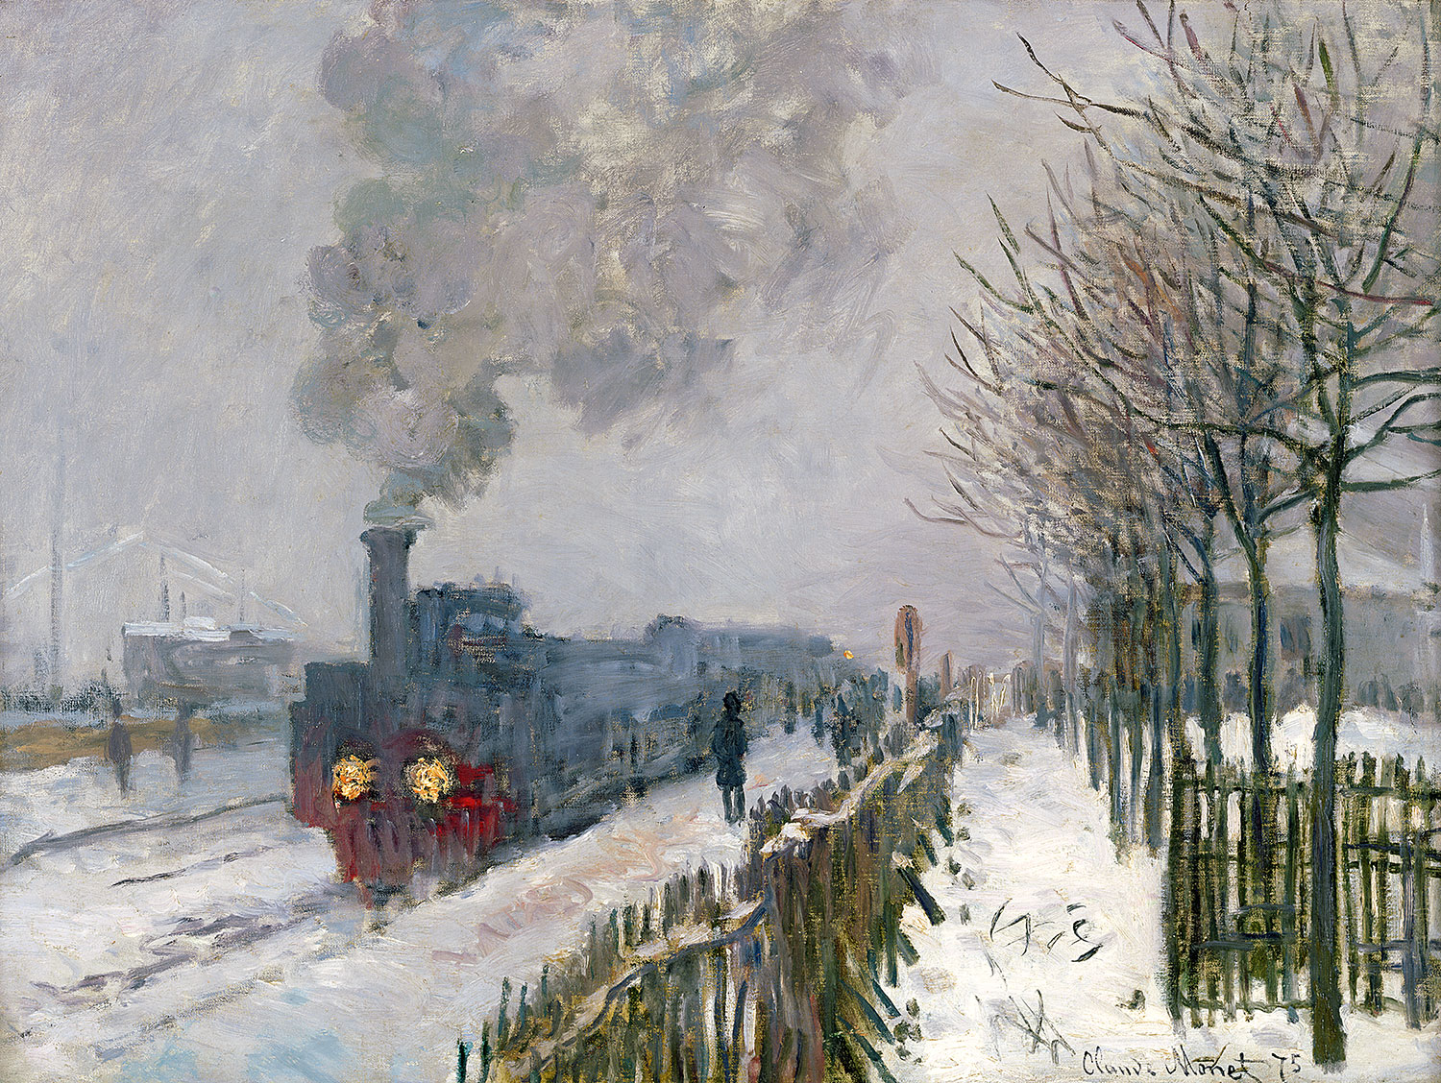  Find an artist who has painted a railway scene and do your own copy of it. Explain why you chose it and why you like it.
Kinesthetic  I enjoy doing hands on activities, sports and dance | Perform your own weather report to the class – focus on the Amazon rainforest, thinking about key aspects of the tropical climate. | Make a 3-D model which demonstrates the different stages of a river from source to mouth. | Design a costume for a dancer performing in a rainforest-themed dance. Collect fabrics that you could use or make part of the costume. | Make a mind map showing the different uses of railways. | Make a model of a famous railway bridge. Can you make it strong enough to carry a weight? | Rainforests are accustomed to a lot of rain. Set up your own weather station at home and measure the daily rainfall and temperature. Record this in tables and graphs.
Musical  I enjoy making and listening to music | Make a list of songs that mentions the word ‘Rainforest’ in the title and maybe play some for us to listen to. | Write a song or poem about rainforests. | Compose a piece of music about a day in the rainforest that can be played using percussion instruments. Think about the sounds you would hear - animals, weather, nature (trees, water) | Watch this ‘story and music’ clip and create your own accompaniment for a river or rainforest story or poem:  https://www.bbc.co.uk/programmes/p011stvj | 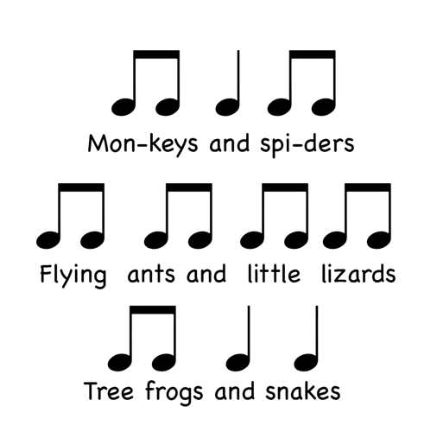  Create and play some rhythms for the different animals living at different layers of the rainforest, e.g. | Listen to some of Handel’s Water Music’ and evaluate how the different instruments contribute to the sound of water.  https://www.youtube.com/watch?v=Kuw8YjSbKd4
Interpersonal  I enjoy working with others | Make a ‘David Attenborough style’ voice-over script for a Rainforest experience. | Make a 3-D model which shows the layers of the Rainforest, from the floor to the emergent layer. | Visit a river and create a tally chart of wildlife that you observe over 30mins. Draw a bar chart or pie chart to present the data. | Go camping! Pretend you are on an expedition. Record your experience. You don’t have to go to a campsite…you could make a camp in your house and sleep in there? | Create a game – a board game or computer-generated. The aim is to help other children learn the key words of a rainforest. | Design and build a shelter for a person living in a rainforest environment. Evaluate how successful it would be when it rains!
Intrapersonal  I enjoy working by myself | Draw and label a diagram of the water cycle. | Make a poster showing the causes and effects of river pollution. | Write an adventure story featuring a railway. Make sure it has exciting events and language to keep the reader engaged throughout. | Draw a map of a rainforest on a grid and label the axis. Draw things on your map and plot their co-ordinates. (Like a treasure map but for the rainforest) | Create a South American inspired recipe which you could try and make at home.  Photograph the finished dish and tell us how it went! | Research a group of people that are indigenous to a rainforest environment. Write about their:  • Shelters • Food • Beliefs and customs • Day to day life – then and now.
Hand-in Dates: 5th May, 19th May, 2nd June, 16th June. Each task should be taken from a different row and a different column.

