Homework Fun for Sycamore Class
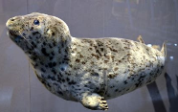  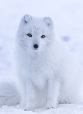  Research an animal that lives in the Arctic or Antarctic. Please present this as creatively as possible.  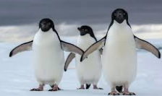 | 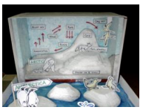  Make a model to show either the Artic or Antarctic environment | Design a board game with an Arctic or Antarctic theme. Make sure there is a maths element to the game.  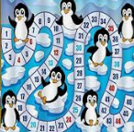
Research, design and create a ‘weather station’ to show the weather.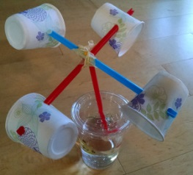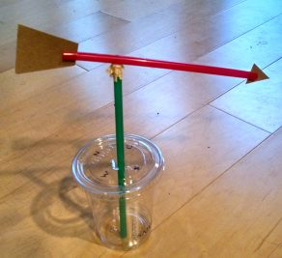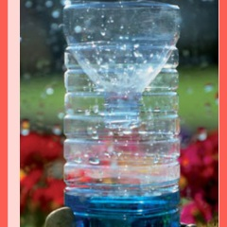 |   Take photographs of wild animal foot prints when you are out for a walk and try to identify them. Then create your own wild animal footprints! |   Can you demonstrate what happens to a material when it changes state by being heated or cooled?    
Create a ‘States of Mater’ (solids, liquids and gasses) quiz (questions & answers)  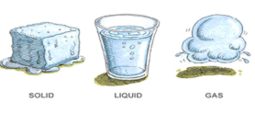 | Paint a picture of an Arctic or Antarctic environment.  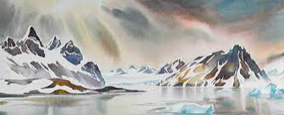 |   Take part in the Great Garden Birdwatch and take some photographs  https://www.rspb.org.uk/get-involved/activities/birdwatch/
Ideally we would like you to complete two of these activities each half-term which would be 4 projects to complete before Easter. We will always try to celebrate homework as soon as practically possible.

