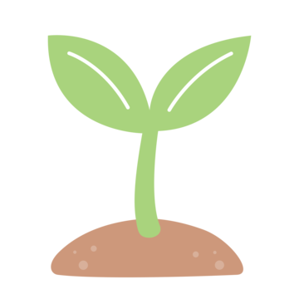

**Rowan Class Summer Term Homework 2025**

**Let It Grow**

Our learning this term will be about Plants and the history of Loxwood!

These activities are designed to develop your learning outside of school, it would be great if you could complete two activities per half term! We are really looking forward to you sharing with the rest of the class all the interesting information you have learnt and the skills you have developed whilst you have done it, enjoy.

|  |  |  |  |
| --- | --- | --- | --- |
| **Create a French menu**  **Can you create a menu in French with all of your favourite foods?**  Ordering at a Restaurant! | **Create a storyboard**  **Can you create a storyboard to summarise a book you have read recently?**  Storyboard Template For Kids + Free Template | Imagine ForestSchool Stack Clipart Transparent PNG Hd, Stack Of School Books, Book,  School, Library PNG Image For Free Download | **Create a collage**  Fair Trade Fruit collage! P2a |**Can you research a famous collage artist and create a fruit or vegetable collage inspired by this artist?** | **Represent the life cycle**  **C:\Users\imalins\AppData\Local\Microsoft\Windows\INetCache\Content.MSO\AB965F9A.tmpCan you design and create a way to represent the stages of the life cycle of a plant?** |
| **Create a sketch map**  **Can you create a sketch map or your local area or an imaginative place? Remember to add a key!**  Pencil PNGs for Free DownloadC:\Users\imalins\AppData\Local\Microsoft\Windows\INetCache\Content.MSO\5E7D6B59.tmp | **Research a historical building**  C:\Users\imalins\AppData\Local\Microsoft\Windows\INetCache\Content.MSO\EDF13FCF.tmpComputer PNGs for Free Download**Can you research a historical building in the UK and tell us about its importance?** | **Create a 3D Model**  **Can you create a 3D model of a plant or a flower? Can you then label the parts you have made?** | **Create a timetable**  Clock Icon PNG Images, Vectors Free Download - Pngtree**Can you create a timetable of your day and the things you get up to during your day? Remember to write the times you do the different things!** |