Science
Properties and Changes in Materials
To compare and group together everyday materials based on their properties and response to magnets; to know that some materials will dissolve in liquid to form a solution, and describe how to recover a substance from a solution. To use knowledge of solids, liquids and gases to decide how mixtures might be separated. To give reasons (based on evidence from comparative fair tests) for the particular uses of everyday materials. To investigate reversible and irreversible changes.
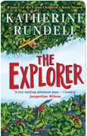
Art
Rousseau
To create sketch books to record observations and use them to review and revisit ideas. To improve mastery of art and design techniques, including drawing and painting.
RE
Creation
To retell the Judeo- Christian story of creation. To retell the Hindu creation story. To compare the creation stories of the Abrahamic religions. To classify the creation stories. To explain Sikh beliefs about creation.

PE
Gymnastics (Y5/6)
Netball (Y5/6)
Tag Rugby (Y5/6)
Basketball (5)

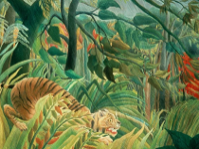
Maths
Multiplication and Division
Multiply numbers up to 4-digit by a 1-digit or 2-digit number when using long multiplication; divide numbers up to 4-digits by a 1-digit number using the formal written method of short division & interpret remainders appropriately for the context.
Fractions
Multiply proper fractions & mixed numbers by whole numbers, supported by materials and diagrams. Calculating fractions of a quantity and using fractions as operators.
Decimals and Percentages
Read, write, order and compare and round numbers with up to three decimal places; recognise the % symbol; write percentages as a fraction.
Perimeter and Area
Measure and calculate the perimeter of composite rectilinear shapes in cm & m; calculate & compare the area of rectangles & estimate the area of irregular shapes.
Statistics
Complete, read & interpret information in tables inc. timetables; solve comparison, sum & difference problems using information presented in a line graph.

DT
Moving pictures
Using the rainforest and its animals as inspiration for a Cam operated animal. To explore and use mechanisms (e.g. leavers, sliders, wheels and axles), in their products.
English
Poetry
- ‘The Tyger’ by William Blake

Explanation and Recounts
- Diary

Persuasive Writing
- Endangered Tigers
- Save our Rainforests
- Stop using Plastics

Non-Chronological report
- Rainforests / Deforestation

Fiction
- Escape to the River Sea by Emma Carroll

Independent Writing
Throughout the term, there will be increasing opportunities for independent writing.

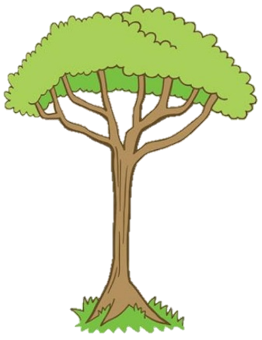
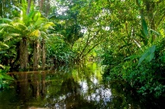
Geography
Rainforests

The children will compare a British forest with the Amazon rainforest, and begin to explore some of the conversation issues surrounding the destruction of rainforest habitats.
History
The Railways
In this unit, children will learn about the development of the Railways in Great Britain and discover the history of the railways and significant early locomotives. Children will investigate some important historical events, such as the opening of the first passenger carrying railway lines and the Rainhill Trials and they will learn about some of the key people who were influential in the development of the railways. In addition to this, they will learn about the development of locomotive technology and examine the differences between steam, diesel and electric locomotives. The children will also learn about the growth and development of the railway network in Great Britain and use their geographical skills to map out some key routes. They will also use their speaking and listening skills to debate the positive and negative effects of the railways on different aspects of society.

Computing
Scratch
To design, rewrite and debug programs that accomplish specific goals, including controlling or stimulating physical systems; solve problems by decomposing them into smaller parts.
French
Let’s Go Shopping
To broaden their vocabulary and develop their ability to understand new words. To engage in conversations; ask and answer questions; express opinions and respond to those of others; seek clarification and help when shopping.
RHE
One World
Fairtrade Fortnight
Keeping Safe
To look at the mysteries of tropical rainforests. From the layers of the forest and its animal inhabitants, to the unique climate found in the tropics.

YEAR 5 SPRING TERM
‘’The Explorer’
Music
Charanga
To play and perform in solo and ensemble contexts, using their voices with increasing accuracy, fluency, control and expression. To improvise and compose music for a range of purposes using the interrelated dimensions of music.

