 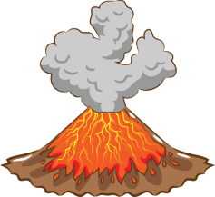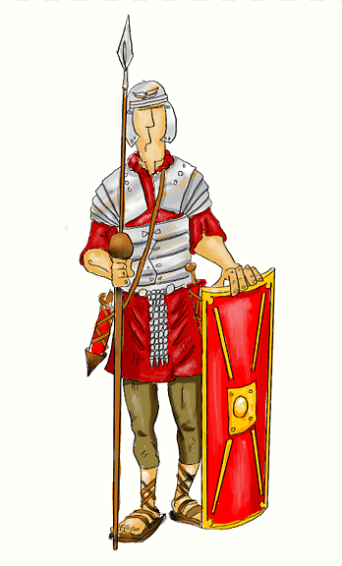

**Art**

We will be developing our drawing skills and learn how to observe and draw the features of the face. We will earn about how lines and shapes help us to draw realistic facial features.

**D&T**

We will be applying different skills to research, design and make an earthquake proof building.

French

We will develop our knowledge of French. Learning how to understand and follow instructions, identify colours ,name parts of the body and say what we are wearing.

RSHE

We will be understanding that we live in a diverse, multicultural and democratic society. We will learn about British people, rules, the law and what living in a democracy means.

**Extreme Earth**

**Year 3 Spring Term 2025**

History

We will be learning about the Romans and their reasons for raiding and invading Britian. We begin by looking at what life was like in early Rome and how the invasion into Britian happened.

Geography

We will be learning about the destructive powers of nature, from volcanoes and earthquakes to tsunamis and tornadoes. We will learn about how and why these natural disasters occur and the way they affect people and the environment.

RE

We will be looking at Sikhism. Developing our knowledge of the story of Rama and Sita and its importance. We will be focusing on the origins of Sikhism, its core beliefs, festivals and special places.

Music

In Music this term we will be developing our Performance singing.

PE

Throughout the Spring Term we will be developing our skills in these areas:

**Netball, Dance, Tag Rugby and Gymnastics.**

.

Computing

We will be introduced to Scratch to develop our coding skills. We will begin to a selection of motion, sound and event blocks to create our own programs, featuring sequences.

English

**Key Texts**

We will be reading a variety of fiction books, as well as non-fiction books and poetry.

**Writing**

We will be looking at writing similar to what we are planning to write. We will then understand and learn about the structure, vocabulary and grammar and use this in our own writing. We will be proof-reading our work to make improvements. This term we will be writing a narrative story, a persuasive letter, poetry and an explanation text all about how the digestive system works.

Maths

**Multiplication and Division**

We will be developing the skill of using reliable written methods for of two-digit numbers by one digit numbers.

**Length and Perimeter**

We will be measuring the perimeter of 2-D shapes, as well as measuring, comparing, adding and subtracting lengths.

**Fractions**

We will begin to understand unit and non-unit fractions.

**Mass and Capacity**

We will further develop our knowledge of measurements looking at mass (kg/g) as well as volume and capacity (l/ml).

Science

**Animals including Humans**

We will be learning about the structure of the human skeleton and how the muscles work alongside the skeleton to support and protect the human body.

**Forces and Magnets**

We will be exploring simple pushes and pulls as an introduction to forces; We will explore how the texture of an object or the surface can affect how the object moves. We will explore different magnets and looking at how they can pull (attract) and push (repel) at a distance without contact.